Technology Project Report (2023-2027)

DermaScanAI Smart SkinCare



BSIET- FALL-(2023)
Submitted by
Momina Aftab FUI-FURC-F23BSET023
Iqra Pervez FUI-FURC-F23BSET014
Fatima Iqbal FUI-FURC-F23BSET010

PROJECT SUPERVISOR
Miss Hira Ansar

Lecturer
Department of Engineering Technology
Information Engineering Technology Program
Foundation University School of Science and Technology
CERTIFICATE OF COMPLETION
This is to certify that this project report entitled “DermaScanAI Smart SkinCare” by Momina Aftab (023), Iqra Pervez (014), Fatima Iqbal (010), submitted in partial fulfillment of the requirements for final year project during the academic year 2023-27, is a bonafide record of work carried out under my guidance and supervision.

Project Supervisor:
Miss Hira Ansar
Lecturer

COPYRIGHT STATEMENT
Copyright in the text of this report rests with the student authors Momina Aftab, Iqra Pervez and Fatima Iqbal of this document (in full or as extracts) may only be made in accordance with the instructions provided by the authors. Furthermore, details can be gained from the project supervisor or the institutional librarian. This page must be included with any such authorized copies. No additional copies (by any process) of materials already reproduced in accordance with these instructions may be made without the prior written permission of the authors. The ownership of any intellectual property rights described in this project rests with Foundation University Islamabad (FUI), subject to any prior agreement to the contrary. These rights may not be transferred or made available to third parties without the written permission of FUI, which will set out the terms and conditions of any such agreement.

STATEMENT OF ORIGINALITY
We namely Momina Aftab, Iqra Pervez and Fatima Iqbal Submitting final year Project Report Phase-1 titled “DermaScanAI Smart SkinCare”. State that we clearly understand what plagiarism is and we have also read about it using online sources. As such, we claim that this entire work (code, reports etc.) is our own effort. We have not used/copy or pasted or paraphrased even a single line of code or sentence from any other source without giving a proper reference to it. Based on our confidence in our originality, we allow the University to run anti-plagiarism software on the report.
We understand that if now, or in the future, ever it is found out that we have not been honest and have plagiarized, the university will take action and will result in disciplinary action, such as the cancellation of our degree and I/we can be liable for any subsequent punishments as deemed appropriate by the University as well as the Higher Education Commission Pakistan.

______________
Signature
Momina Aftab
Date:

______________
Signature
Iqra Pervez
Date:

______________
Signature
Fatima Iqbal
Date:
ABSTRACT
This project addresses a critical challenge in healthcare like a skin disease in medication so, “DermascanAI Smart SkinCare” is a skincare application that uses intelligence to help people figure out what is going on with their skin. It looks at pictures of your skin. Tries to determine if you have any skin problems. The system is smart enough to tell if a picture is not actually of skin, which helps it make predictions. DermascanAI Smart Skincare also has a feature that asks you questions about your skin and then tells you what type of skin you have, like dry skin. Based on your skin type it gives you personalized tips on how to take care of your skin. The application can even scan the ingredients of skincare products. Explain what they do if they are good for you and if they have any bad side effects. This helps you make choices when buying skincare products. If you have any questions about your skin DSAISS has a chat feature that can answer them. It can also give you tips on how to take care of your skin based on the weather. You can use DSAISS to schedule your daily skincare routine. It will remind you to stick to it. It even keeps track of how days in a row you have followed your routine. The main goal of DSAISS is to help people take care of their skin and catch any problems early. It is, like having a personal skincare helper that uses intelligence to give you the best advice. DSAISS is a tool that makes taking care of your skin easier and more accessible.

ACKNOWLEDGEMENTS
We begin by expressing our profound gratitude to Almighty Allah for His infinite blessings, wisdom, and guidance, which have been the foundation of our perseverance and success. It is through his mercy that we were granted the strength, patience, and determination to accomplish this project. His divine blessings have always been guiding lights on our path in times of confusion and difficulty. We would like to thank our revered supervisor, Miss Hira Ansar, from the bottom of our hearts for the guidance and support she provided us during the whole process of developing this project. We highly appreciate her professional knowledge, her valuable suggestions, and the assistance she gave us through her dedication and hard work. We would also like to thank our families and our loved ones for being there for us and supporting us with patience and motivation all along. It was their motivation that kept us going strong and helped us keep focused on our aim. Finally, we wish to thank Almighty Allah, our beloved supervisor Miss Hira Ansar, and our families again for their prayers, guidance, and moral support throughout this journey.
Thank you.

Table of Contents
CHAPTER 1
INTRODUCTION
1.1 Objectives of the Project 2
1.2 Technology Stack 3
1.3 Scope of the Project 4
1.4 Significance of the Project 5
CHAPTER 2
LITERATURE REVIEW
2.1 Background of the Study 6
2.2 Problem Statement 13
CHAPTER 3
SYSTEM ANALYSIS & METHODOLOGY
3.1 Tools & Technologies 14
3.1.1 Frontend Ecosystem 15
3.1.2 Backend Services 15
3.1.3 Database & Cloud Storage 15
3.1.4 Data Collection 16
3.1.5 Data Preprocessing 16
3.1.6 Model Use 17
3.1.7 Late Fusion 17
3.1.8 Performance Assessment 17
3.2 System Requirements 17
3.2.1 Functional Requirements 17
3.2.2 Non-Functional Requirements 19
3.3 Methodology 19
3.3.1 Use-Case Diagram 19
3.3.2 Sequence Diagram 31
3.3.3 Activity Diagram 35
3.3.4 ER-Diagram 36
CHAPTER 4
IMPLEMENTATION
4.1 User Interfaces 37

CHAPTER 5
TESTING
CHAPTER 5 45
5.1 User Signup 46
5.2 User Signup-Negative Testing 47
5.3 User Login 48
5.4 User Login-Negative Testing 49
5.5 Skin Disease Analyzer 50
5.6 Skin Disease Analyzer-Negative Testing 51
5.7 Smart Ingredient Scanner 52
5.8 Smart Ingredient Scanner- Negative Testing 53
5.9 Skin Type Detector 54
5.10 Skin Care Assistant 55
5.11 Skin Routine Schedular 56
5.12 Weather-Based Skin Tips 57
5.13 Streak Tracking System 58
CHAPTER 6
CONCLUSION
6.1 Future Direction & Strategic Growth 59
6.2 Proposed Solution & Anticipated Results 60
References…………………………………………………………………………...61

LIST OF TABLES
Table 1: Benchmark Table 11
Table 2: Functional Requirements 19
Table 3: Non-Functional Requirements 20
Table 4: UC01 Signup 22
Table 5: UC02 Login 23
Table 6: UC03 Skin Disease Analyzer 24
Table 7: UC04 Skin Type Detector 25
Table 8: UC05 Smart Ingredient Scanner 26
Table 9: UC06 Skin Routine Schedular 27
Table 10: UC07 History 28
Table 11: UC08 Weather-Based Skin Tips 29
Table 12: UC09 Streak Tracking System 30
Table 13:UC10 Skin Care Assistant 31
Table 14: Test Case 1 Signup 47
Table 15: Test Case 2 Negative Signup 48
Table 16: Test Case 3 Login 49
Table 17: Test Case 4 Negative Login 50
Table 18: Test Case 5 Skin Disease Analyzer 51
Table 19: Test Case 6 Negative Skin Disease Analyzer 52
Table 20: Test Case 7 Smart Ingredient Scanner 53
Table 21: Test Case 8 Negative Smart Ingredient Scanner 54
Table 22: Test Case 9 Skin Type Detector 55
Table 23: Test Case 10 Skin Care Assistant 56
Table 24: Test Case 11 Skin Routine Schedular 57
Table 25: Test Case 12 Weather-Based Skin Tips 58
Table 26: Test Case 13 Streak Tracking System 59

LIST OF FIGURES
Figure 1: Flowchart of Tools & Technologies 15
Figure 2: Flowchart of Data Cleaning 17
Figure 3: Use Case diagram 21
Figure 4: Signup Use Case 22
Figure 5: Login Use Case 23
Figure 6: Skin Disease Analyzer Use Case 24
Figure 7: Skin Type Detector Use Case 25
Figure 8: Smart Ingredient Scanner Use Case 26
Figure 9: Skin Routine Schedular Use Case 27
Figure 10: History Use Case 28
Figure 11: Weather-Based Skin Tips Use Case 29
Figure 12: Streak Tracking System Use Case 30
Figure 13: Skin Care Assistant Use Case 31
Figure 14: Sequence Diagram-1 32
Figure 15: Sequence Diagram-2 33
Figure 16: Sequence Diagram-3 34
Figure 17: Sequence Diagram-4 35
Figure 18: Activity Diagram 36
Figure 19: ER Diagram 37
Figure 20: User Interfaces 38
Figure 21: Splash Screen 39
Figure 22: Splash Screen 2 39
Figure 23: Login & Signup Screen 40
Figure 24: Dashboard Screen 40
Figure 25: Drawer Navigation-1 41
Figure 26: Drawer Navigation-2 41
Figure 27: Skin Disease Analyzer Screen-1 42
Figure 28: Skin Disease Analyzer Screen-2 42
Figure 29: Smart Ingredient Scanner Screen 43
Figure 30: Skin Type Detector Screen 43
Figure 31: Skin Care Assistant Screen 44
Figure 32: Skin Routine Schedular Screen 44
Figure 33: Streak Tracking System Screen 45
Figure 34: Weather-Based Skin Tips Screen 45
Figure 44: Flowchart of Testing Features 46

CHAPTER 1
INTRODUCTION
Here in this chapter, the reason behind the increasing trend of dermatological issues due to poor skincare practices, diverse environmental conditions, and lack of accessibility to medical consultations is being analyzed. The major majority of people cannot adopt appropriate skincare routines due to lack of knowledge or future guidance that can complicate their skin problems and hinder any effective treatment. Moreover, improper use of cosmetic products, wrong perception about skin qualities, and inadequacy of smart tools to assess skin problems may result in skin disorders.
The health of the skin has significant importance in preserving one’s general health; however, it is often ignored in everyday life. Many individuals ignore the signs of developing problems with their skin at an early stage, and this may lead to further complications. The unique cause for this is the costliness of dermatology visits. Another challenge is the lack of medical facilities in rural and underdeveloped areas (Ulfah A et al., 2025), where access to dermatologists is very limited. In such situations, people need an easy and affordable solution that can help them identify skin issues at an early stage. So, we proposed project, “DermaScanAI Smart SkinCare”, aims to provide a mobile based system that allows users to detect skin problems, track their skin health, and receive timely guidance for better care.
The mobile application DSAISS will use Artificial Intelligence (AI) to analyze skin conditions (Escalé-Besa et al., 2024). That allows people to upload or scan images of their skin for disease detection. The AI system will then detect possible skin diseases in a quick and easy way, and our application is also analysis the people’s skin type and will provide skincare tips based on some quiz for example asking some questions from user about the skin conditions. If it identifies any minor or skin problem, it will recommend primary medicines or products that can be used securely. Our model detects six common skin diseases that are prevalent worldwide, based on some perceptions that gathered from diverse dermatological research articles. The DSAISS system targets disease are Acne, Benign Tumors, Eczema, Lichen, Scabies, and Vitiligo. This app will analyze these diseases and give instant results. This approach is rapid, reliable, and user friendly.
For adding additional features to the app we make our application to notify peoples with skincare tips. These notifications will be based on the weather conditions in their current area. For instance, it may remind them to apply sunscreen during hot weather or moisturizer in dry weather. Our application will also provide a product ingredient safety checker to help users to make their skincare better. By scanning skincare products, the DSAISS system will scan their ingredients and inform users if they are secure for their skin type. It will also emphasize any harmful chemicals, that allow users to avoid products that could cause inflammation. Another feature that we add to our project is Skin Care Assistant that uses intelligence to help people with their skin.
CHAPTER 1
INTODUCTION
The Skin Care Assistant can answer questions about skin tell people what to do about skin problems suggest skincare routines and recommend products that're right, for them. This makes it easy for people to get help with their skin when they need it.
By making our project supportive and more helpful we add a feature named Skin Routine Schedular in our project, users can set their morning and as well as night routine schedule like set a routine of using some moisturizers or also can set doing exercise reminder manually, anything user want to remind for their skin or health they can use this feature. The DSAISS also has a streak tracking system. This system helps people stick to their skincare routine by keeping track of what they do every day. It shows how days in a row they have followed their routine. All these things help people take care of their skin better. They make sure people do their skincare routine every day. The DSAISS is easy to use and fun because of these features. DSAISS really helps people develop skincare habits. The DSAISS makes it easy for people to take care of their skin.
In our concept, we choose to create an application that if it registers with any serious or risky skin problem, it will provide guidance to the people to visit any dermatologist in urgent needs. Failing to take care of your skin or to treat it early may aggravate skin problems, and cause infections, scars or even chronic skin diseases. The app won't substitute for doctors, rather a first step to resolving issues. It makes sure that individuals know when they are in need of immediate medication. This ensures DSAISS's safety and reliability.

Objectives of the Project
This project is directed by some key questions that delineate the purpose of the proposed DSAISS system.
- Q1: How can artificial intelligence help peoples to take care of their skin in personalized way?
- Q2: Is it possible to detect skin disease by using image based detection?
- Q3: How can someone identify his skin type without clinical testing?
- Q4: How can an AI-powered skincare assistant provide instant guidance and answers for user skincare concerns?
- Q5: What is the best way the user follows or manages effectively his daily skincare routines?
- Q6: How environmental problems effects skincare recommendations and tips?
- Q7: How can users be aware about the safety of skincare product ingredients that he wants to uses?
- Q8: How can modern skincare techniques be made user-friendly and budget-friendly for all users?
Objectives of the study have been formulated in such a way that they answer these above-stated questions in an effective manner, such as designing an intelligent AI-powered skincare system, which is able to identify different skin problems and types,
CHAPTER 1
INTODUCTION
and provide personalized suggestions for the enhancement of skin health and management, and some of them are mentioned below:
- O1: AI Skincare Solutions is design an AI based mobile application that suggest personalized skincare tips and suitable products based on skin condition and type.
- O2: Skin Disease Analyzer to create an AI mobile app that can detect and analyze skin diseases from the uploaded images.
- O3: Skin Type Detector to identify the skin type of the user like oily, dry, combination, and sensitive skins through some questions asked on their skin.
- O4: A skincare assistant that uses intelligence helps people with their skin by answering their questions. It tells them what they can do to take care of their skin and suggests products that might be good for them. The skincare assistant also gives people information about skin problems they're worried about.
- O5: Skin Routine Schedular can set morning and night routine like using moisturizer at a specific time and can also set your routine manually.
- O6: Weather Based Skincare Tips helps by send weather based skincare recommendations and alerts that notify users according to local conditions such as sunscreen reminders on hot days.
- O7: Product Ingredient Scanner is use to integrate a product ingredient safety checker to alert users about safe and harmful chemicals in skincare products.
- O8: To maintain Accessibility and Affordability, develop a simple and budget friendly skincare system that can be easily accessed and used by individuals of all age groups, including the elderly.

1.2 Technology Stack
For making a mobile application there are some tools and technologies may require. So, there are some modern tools and technologies we will use to develop our project to make assure performance, convenience and accuracy. We used React Native for front end of our system, that providing a responsive and user friendly mobile interface. TypeScript is the main programming language for the application logic, and Expo helped us to develop and test quickly. For data storage and management, we will use AsyncStorage, Firestore and Firebase that utilized to securely store user profiles, skin analysis records, and routine schedules as well. The AI based skin analysis and product ingredient evaluation were implemented using some machine learning models, by trained on dermatological datasets to classify skin disease and detect potential skin issues. We are using LLM for skin type detection and many other features and CNN like MobileNetV1 for image processing (Sangers T et al., 2022), because there are some other models like YOLOv7 are using but it is only for object detection as demonstrated by previous work on acne detection and dark circle segmentation (Mikhaylevskiy & Pavlishen et al., 2023). For product ingredient scanner we used OCR model for text scanning. REST APIs were used to enable communication between the mobile application and the backend services and for weather based recommendations.
CHAPTER 1
INTODUCTION
Firstly, we design a user interface UI Designing for the look of our application, we will also use a clear and attractive logo to give the app a professional identity so we used Figma, and Canva employed for UI/UX design and prototyping, assuring consistent and intuitive user engagement throughout the application. and we made simple frontend with a user friendly interface to make scanning and navigation simple, and strong backend that will handle image processing AI models, and secure data storage as well.

1.3 Scope of the Project
The scope of our project DDAISS is a smart personal skin care assistant, it functions as an AI powered skin care assistant which increases the self-awareness of the user, encourages taking preventive measures and skin health into the long term. Our project is centered around the below:
- Skin Image Scanning and Disease Detection: The system can scan or upload images of the skin which are processed with state of the art AI algorithms to identify common skin diseases. This module helps consumers detect their skin problems in the early stage and prompt them to take action to improve the management of their skin.
- Skin Type Recognition and Skincare Recommendation: Such a smart system will be capable of understanding the type of your skin, whether it is an oily, dry, or sensitive one, through the questions that it will ask from you. According to this, the DSAISS system will give recommendations about your treatment and skincare products.
- Product Ingredient Scanning: The products' descriptions may be analyzed to assess their suitability for the users' skin types or conditions. The DSAISS analyzes the components in the products that are either harmful or beneficial to users, and offers guidance on safer products.
- Weather Based Notifications: The application combines the current weather data with the result and provides weather-dependent skin care alerts, depending on the temperature, humidity. These notifications assist users in adapting their skin care regime by taking into account the changing environments, and moreover providing proactive skin protection.
- Skin Care Assistant: The Skincare Assistant is a computer program that helps people with their skin. You can ask the Skincare questions about your skin. You can ask about things that're wrong with your skin or how to take care of it. The Skincare Assistant will give you advice that's just for you. It will tell you what to do based on what you tell it about your skin. The Skincare Assistant can also help you understand what is in the products you use on your skin. It will tell you what to watch out for if you have skin problems. It makes taking care of your skin and you will know more about what you are doing.
- Skin Routine Schedular: The application provide The Skin Routine Scheduler feature helps users maintain a consistent skincare routine by allowing them to set morning and night routines manually. It provides timely reminders for essential skincare activities like cleansing and moisturizing etc. Users can also
CHAPTER 1
INTODUCTION
manually adjust their routines according to personal preferences or dermatologist advice. The attribute is a major contributor to secure skin care and lasting skin health maintenance.

1.4 Significance of the Project
It is evident from the above that the DSAISS provides a smart and user-friendly method for skin identification and skincare treatment of people. With its help, individuals will be able to identify harsh issues related to skin at an early stage, and also be able to take care of their skins using the right skincare regime according to their personal needs.
The system's ability to integrate artificial intelligence, weather-based tips and ingredient analysis and scanning presents a seamless approach to dermatological science and real-world skincare. It's a budget-friendly and convenient platform to encourage good skin care and healthy skin habits, and to start care before it starts to become an issue. Moreover, this project highlights the reframing potential of AI in healthcare, also make the smooth way for advancements in AI driven dermatology and cosmetic technology.
CHAPTER 2
LITERATURE REVIEW
To ground the project, literature relevant to skin disease detection and mobile health applications are reviewed. It examines previous research studies, existing diagnostic systems, and technological approaches used in dermatology. The chapter highlights the strengths and limitations of methods as well as AI based solutions and also from where they get datasets and their accuracy. It also depicts the gap in current systems that justify the need for a more and advanced accessible and user-friendly skin disease application. All in all, this chapter shows how the project fits with existing research and also points out some area, where they it should be improved.

2.1 Background of the Study
The skin is really important to our body it helps keep us safe from things and it also shows how healthy we are. Lately a lot of people have been having skin problems because of the way the world is changing and how dirty it is getting and also because people are not taking care of themselves. We see things, like acne and eczema and skin color changes and allergic reactions happening to people of all ages. These things can really affect how we look and feel about ourselves. This is why we need to find ways to take care of our skin that really work and that everyone can use so people can take care of their skin every day.
Traditional skincare practices completely based on visual assessment or consultation with dermatologists, which might be not always be suitable for everyone. Many peoples face difficulties in accessing medical care due to consultation expenses, and regional limitations and awareness gap as well. As a result, mild skin issues are often neglect untreated until it formed into more serious conditions. This situation focuses the need for an innovative, affordable, and user friendly approach that empowers peoples to be aware of their skin and receive trustworthy recommendations without having a frequent clinical visits.
With the accelerated expansion of Artificial Intelligence AI and Machine Learning MI infrastructures, such as TensorFlow have made it enable to create advanced models for image classification and analysis (Marri S. S et al., 2024). Deep Learning frameworks for instance CNN, MobileNet, ResNet50, are broadly used for dermatological image detection as they are capable to identify faint skin features with precise and high accuracy. AI based skincare analysis systems are reshaping skincare by providing instant consequences, personalized, and data based recommendations directly to users. The DSAISS employ these advanced technologies to provide extensive and comprehensive skin assessment and guidance through a mobile application. The DSAISS bridges the gap between cutting-edge technology and dermatological treatment and encourages healthy skin care in an easy, convenient, and accessible way by functioning with the help of AI-powered detection and functional skin care suggestions.
CHAPTER 2
LITERATURE REVIEW
The Use of Artificial Intelligence for Skin Disease Diagnosis in Primary Care Settings” by Escalé-Besa et al., 2024 looks at AI-based approaches for diagnosing skin diseases. There are new solutions to skin conditions in care. This review followed the PRISMA guidelines. The researchers tested the accuracy of AI algorithms in the diagnosis of skin diseases. They looked at studies published from 2012 to 2022. They also assessed the risk of bias on the basis of QUADAS-2. AI applications are used for diagnosis assistance and triage. Most AI models are trained on images, from image datasets. We need research to make sure these algorithms are reliable. It's also important to test these tools in real-life situations [1].
An artificial intelligence based app for skin cancer detection evaluated in a population based setting by Smak Gregoor AM et al., 2023 Investigates the practical effects of an AI-driven mHealth application designed to detect skin cancer. Algorithms based on artificial intelligence (AI) used to classify suspicious skin lesions have already been applied in mHealth applications. In order to assess the effect on dermatology healthcare utilization, we performed a retrospective pragmatic study on the population. We found that users of the mHealth application (n = 18,960) made significantly more dermatological claims for (pre)malignant skin lesions than the non-users (controls; n = 56,880). Specifically, the studied mHealth application called SkinVision employs a convolutional neural network (CNN) that is able to classify images of skin lesions into two classes according to their risk of developing skin cancer. Recently, the CNN’s accuracy was estimated to be 87–95% sensitive and 70–78% specific.” [2].
Increasing Awareness and Early Detection of Common Skin Diseases in Indonesia Through an mHealth App by Ulfah Abqari et al., 2025 has a primary objective of developing a mobile application known as DEDIKASI app for purposes of creating awareness on skin-related diseases such as leprosy, as well as assessing its acceptability and effectiveness. This research intends to determine the level of awareness before, acceptability of the mobile application by community members and health workers, as well as its efficacy in increasing awareness on skin diseases. This research will be implemented through four stages including development of DEDIKASI app, development of a questionnaire to measure the level of awareness of skin diseases among the community, awareness and acceptability testing of DEDIKASI app, and finally a randomized control trial of DEDIKASI app. Design thinking approach will be adopted in developing the application [3].
Worldwide trends and future projections of fungal skin disease burden: a comprehensive analysis from the Global Burden of Diseases study 2021 by Deng Li et al., 2025 investigates how common fungal skin diseases are globally and what the future might hold. Fungal skin diseases are a health problem, worldwide, and are primarily caused by dermatophytes, yeasts and molds. This study was conducted to determine how many people would have skin diseases in 2021. It also examined changes in these diseases between 1990 and 2021, and attempted to forecast future trends. Using linear regression models, the researchers were able to observe change over time. They found out that males had fungal skin diseases than females when looking at how many people
CHAPTER 2
LITERATURE REVIEW
got the disease how many had it and how much it affected their lives. The study used data, from the Global Burden of Diseases study 2021 to get its information. Fungal skin diseases are a problem worldwide and this study helps us understand how big of a problem they are. Males had age-standardized rates for incidence, prevalence and disability-adjusted life years (DALYs) compared to females. Projections suggest significant increases in incidence, prevalence, and DALYs, notably in middle- and low-income regions [4].
Validation of a Market-Approved Artificial Intelligence Mobile Health App for Skin Cancer Screening by Sangers T et al., 2022 evaluates the use of a CE-marked mHealth application that uses a convolutional neural network to identify precancerous or cancerous skin lesions. Consumer-based mobile health applications (mHealth) have been utilized along with deep learning algorithms in assessing risks of developing skin cancers. Nonetheless, future prospective validation of these devices is required. Lesions were identified using the mobile application after clinical diagnosis but prior to conducting any histopathological evaluation of the lesion. The results obtained from the mobile application were then compared to the histopathological findings or, failing this, the clinical findings made by the dermatologist. Studies on the implementation of mHealth in the lay community must also be conducted [5].
The article Artificial Intelligence in Cutaneous Leishmaniasis Diagnosis: Developments and Future Perspectives by Talimi H et al., 2024 is really helpful. It looks at how Artificial Intelligence's used to diagnose Cutaneous Leishmaniasis. This is a problem for health all around the world. There is a need to establish a method of diagnosis. The authors of the article want to make readers aware of its usefulness. They also wish to discuss the Artificial Intelligence algorithms employed for this. Their study revealed that there were few studies that utilized the Artificial Intelligence algorithms for diagnosing this problem. With the implementation of Artificial Intelligence, it can help the people in regions where this disease is prevalent. The article discusses the current state of Artificial Intelligence for the diagnosis of skin infections, and its potential future development. It is about Artificial Intelligence and how it can help with Cutaneous Leishmaniasis diagnosis [6].
Efficacy of an Artificial Intelligence App (Aysa) in Dermatological Diagnosis: Cross-Sectional Analysis by Marri SS et al., 2024 evaluates the effectiveness of the Aysa AI app as a preliminary diagnostic test for different types of dermatological disease in a semiurban Indian town. Dermatology is a perfect field for artificial intelligence (AI) technology for image recognition in order to enhance the effectiveness of diagnosis and provide more accurate information about diseases. The purpose of the current study is to assess the efficiency of the Aysa AI app as a preliminary diagnostic aid for different types of skin problems in a semiurban town in India. Images of lesions on people suffering from different types of skin diseases were uploaded to the app, while having their informed consent. A total of 700 patients participated in the study [7].
CHAPTER 2
LITERATURE REVIEW
A novel deep learning approach for automatic early detection and classification of skin cancer lesions from dermoscopy imagery by Al Waisy AS et al., 2025 describes Skin DeepNet, a new deep learning framework, designed to aid the doctor in identifying skin cancer at an early stage. This is achieved through computer analysis of skin imagery. Skin cancer affects many people globally, and it is necessary to identify them at their early stages. According to the authors, the deep learning approach described above is an algorithm for the use of computers in analyzing images of skin for identifying skin cancer. In the process of making this identification Skin DeepNet performs two main operations on the images analyzed. First, the images undergo image enhancement, which improves the quality of the images. The images then pass through several filters, including Mask R CNN and GrabCut filter. Skin DeepNet plays a critical role in helping identify skin cancer at an early stage. Skin cancer is an emergency, and it needs to be identified so that appropriate measures can be taken [8].
Deep Learning Approaches for Skin Lesion Detection by Vieira J et al., 2025 proposes a benchmarking analysis of the different deep neural networks used in automating skin lesion classification. In the recent past, an increase in the number of people suffering from skin cancers has been witnessed, and early diagnosis is important since it increases the chances of being cured. The paper proposes a benchmarking analysis of the different architectures of Convolutional Neural Networks (CNNs) that have been applied to automate skin lesion classification. A total of 38 CNN architectures belonging to 10 different categories were tested by transfer learning on the HAM10000 dataset [9].
Use of convolutional neural networks in skin lesion analysis using real world image and non-image data by Samantha C.Wong et al., 2022 examines CNN models that classify benign and malignant skin lesions using real-world imagery and clinical data. Performance of CNNs for the purpose of binary (benign/malignant) lesion classification using real-world imagery is essential when developing an effective CDS application. We designed a CNN utilizing real-world images captured via a smartphone along with ground-truth pathology data and examined whether additional structured EHR data could be beneficial to its performance. Comparison was made between CNN model accuracy and three board-certified dermatologists for validating its clinical relevance. Additional clinical data did not significantly enhance CNN image model performance [10].
A Mixed-Methods Pilot Study on an mHealth App (eSkinHealth) for Skin Disease Diagnosis and Management in Rural Côte d'Ivoire, Africa by Rie R Yotsu et al., 2023 examines the effectiveness and usability of the mHealth app, eSkinHealth, used for the diagnosis and management of skin NTDs and other skin conditions. The main objective of the pilot study is to conduct a study on the usability and effectiveness of the application in rural Côte d'Ivoire for the diagnosis and management of skin NTDs and other skin conditions. The usability study focused on conducting assessments on the system using the System Usability Scale (SUS) as well as through in-depth interviews. The main objective of the effectiveness study was to assess the diagnosis and management of 5 skin NTDs, including Bruli ulcer, leprosy, scabies and yaws [11].
CHAPTER 2
LITERATURE REVIEW
Skin Cancer Diagnostics with an All- Smartphone Application by Upender K et al., 2019. The aim of this paper is to develop software where we can detect skin cancer using a mobile phone. First, the software is capable of taking pictures of the skin lesions either using a camera or by importing images. Afterward. Separating those images for further analysis of lesions. The classification model uses ABCD criteria: Asymmetry, Border, Color variations, and Diameter. For getting more information. A Support Vector Machine classifier algorithm was employed to classify whether or not a particular skin lesion was malignant or benign. The dataset employed is comprised of skin lesion images available publicly in order to train and test our model. From the results obtained, the system shows a sensitivity of 80%, a specificity of 90% and an overall accuracy of 88%. The model is also efficient, being able to process images faster than a second in Android phones. The drawbacks of this system include dependency on quality of images, lighting, and smartphone camera's resolution [12].
Skin Disease Recognition” by lqrhy3 (GitHub project, 2025). This project aims to detect acne and recognize dark circles under the eyes using machine learning and image processing. For acne detection, it uses the YOLOv7 object detection model to locate acne in facial images. The dataset for acne detection is the acne04 dataset, consisting of facial images with corresponding bounding box annotations. The working involves converting raw acne04 data into VOC and YOLO formats and training/evaluating the YOLOv7 model for object detection. For dark circles recognition, an unsupervised no-ML approach was used due to low quality ground truth masks and data privacy concerns about the dataset. Limitations include the lack of shared dataset for dark circles and reliance on a non-ML method for that part due to poor masks [13].
Summer and spring elbow rashes is a variant of polymorphous light eruption: confirmation by photoprovocation and histopathology in a series of five cases by de Gálvez et al., 2023. This article tries to show the participation of ultraviolet A rays in developing this form of polymorphous light eruption only in the elbow region. The work entailed phototesting and photoprovocation of lesions by exposing the patients to Philips UVA HPA Lamp (400 W). This research used models/methods such as punch biopsy, histopathological and immunohistochemistry using anti CD123 which are not artificial intelligence but some are techniques used in research. The data set was comprised of a series of five cases of polymorphous light eruption with lesion only on their elbows. There was no immunohistochemical expression of CD123 in any of the cases. The limitations are few patients and use of one type of light only [14].
Artificial Intelligence Smartphone Application for Detection of Simulated Skin Changes: An In Vivo Pilot Study Gabriela Lladó Grove et al., 2024. The goal of this pilot study was to assess the possibility of using the SCAI mobile application to detect artificial skin spots through an experiment conducted in a controlled environment via a phone application along with AI algorithms from the backend. The system functions on the principles of collecting images from smartphone camera. The database included 24 healthy subjects with 192 artificially applied spots to backs and legs [15].

CHAPTER 2
LITERATURE REVIEW
Table 1: Benchmark Table
Author/Year | Title | Techniques | Dataset | Accuracy |  | Limitation
Escale Besa A, Vidal-Alaball J et al., 2024 | Use of AI for Skin Disease Diagnosis in Primary Care Settings | CNN’s, DNN’s | Multiple datasets | Accuracy: 41%-93% |  | • Mixed datasets  • Low diversity  • Not real world images
Smak  Gregoor AM, Sangers TE et al., 2023 | AI based for skin Cancer Detection | CNN for skin lesion | Real user uploaded smartphone photos. | Specificity ~ 70%–78% (as reported in validation) |  | • False positives rise  • Costly follow up  • Data heterogeneity
Ulfah  Abqari, Isfandiari MA et al., 2025 | Increasing Awareness & Early Detection of Skin Disease | Planned randomized controlled trial (RCT) | Community participants and health care workers in one district. | N/A |  | • Digital literacy issues  • Limited to one rural district  • No blinding (possible bias)
Deng Li, Siqi Fan et al., 2025 | Worldwide trends & future projections of fungal disease | N/A | Global level data from Global Burden of Disease Study | N/A |  | • No individual level images/data  • Cannot assess diagnostic methods
Sangers T, Reeder S et al., 2022 | Artificial Intelligence Mobile Health App for Skin Cancer Screening | CNN’s | Images captured on smartphone devices. | Overall, 76.2% | Paid, Detect only one disease.
Talimi H, Retmi K et al., 2024 | AI in Cutaneous Lesions diagnosis | AI, Deep Learning, CNN’s | Multiple published CL image datasets. | N/A | • Few CL studies  • Different datasets
Marri  S. S, Albadri W et al., 2024 | Aysa | AI-based image analysis and ML (neural network) | 700 patients in dermatology clinic. | All 8 suggestions are equal to 95%. | Poor performance for derma photos image quality variable.

CHAPTER 2
LITERATURE REVIEW
Al-  Waisay AS,  Al-fahdawi S et al., 2025 | A deep Learning Framework For automated early diagnosis | Mask R-CNN, GrabCut HRNet, attention Deep Belief Network | ISIC 2019 dataset and HAM10000 dataset | ISIC 2019 ~ 99.65%, HAM10000 ~ 100% | Works only with dermoscopy
Vieira J, Mendonca F., et al., 2025 | Deep Learning Approaches for skin Lession Detection | CNN’s,  39 pre trained architecture | HAM10000 | 87.62% overall accuracy | Class imbalance in dataset.
Samantha C.Wong et al., 2022 | Use of convolutional neural networks in skin lesion analysis | CNN’s | Real world clinical, derma images. | Sensitivity ~ 79%, Specificity ~ 64% | Skin tone bias.
Rie R. Yotsu, Almamy D et al., 2023 | An mHealth App (eSkinHealth) for Detecting and Managing Skin Diseases | N/A | Clinical images | N/A | • No quantified diagnostic accuracy  • Pilot / small scale study
Upender K, Legner C et al., 2019 | Skin Cancer Diagnostics with an All Inclusive Smartphone Application | A traditional machine learning algorithm, SVM support Vector Machine. | Public derma images, 200 images from PH2 dataset. | With SMOTE-88%  Without SMOTE-90% | • Needs extra 10× lens for images.  • Tested only on derma images.
Mikhaylevskiy S, Pavlishen V et al., 2023 | Skin Disease Recognition | YOLOv7 | ACNE04, publically dataset + private dataset for dark circles. | N/A | Limited to acne and dark circles only.

CHAPTER 2
LITERATURE REVIEW
de Gálvez MV, Castillo-Muñoz RM et al., 2023 | Summer and spring elbow rashes is a variant of polymorphous light eruption | N/A | Dermatology clinic patients, 5 real cases. | N/A | • Only Five cases  • Limited demographic
Gabriela Lladó Grove, Reedtz G., 2024 | SCAI-App  Artificial Intelligence Smartphone Application for Detection of Simulated Skin Changes | CNN’s | Volunteer skin images. | Sensitivity 92.0%, Specificity 95.5%,  Negative Predictive  99.7%,  Positive Predictive  38% | •Tested only on simulated spots  •Low PPV  •May not work in varied lighting/angles

2.2 Problem Statement
Skin diseases are very common around the world and affect many people every day. And by research all of these articles and existing apps, and by measuring their limitations like many times, people cannot visit a dermatologist because the checkup is expensive or the facility is far away. When they delay finding out the problem, a small issue can become worse and harder to treat. Reports also show that millions of people suffer from untreated skin problems, especially in rural areas. Right now, there is no simple and easy system that helps people quickly check their skin at home. There were some existing apps are either costly or lack of full features like skin type detection and skin routine schedular and health tracking as well. Additionally, users are unaware of how environmental factors like humidity and other dry weather affect their skin or whether a product’s suit their skin type or harsh for them. Because of this problem, people cannot maintain and care about their skin properly, and the problem becomes getting worse over time.
In addresses these difficulties, DSAISS is a system that offers a cost-effective and smart method of early skin detection. Through DSAISS, users can scan and diagnose any skin diseases and determine their skin type through the concept of quizzes. The DSAISS system also boosts the level of self-care among the users through personalized advice on skincare.

CHAPTER 3
SYSTEM ANALYSIS AND METHODOLOGY
This chapter will provide information regarding the system analysis and methodology of the development process for the DSAISS project that provides a detailed view on the design and requirements of the system. The discussion will focus on system requirements, as well as functional and non-functional requirements to ensure that the system meets the needs and performance criteria of its intended users. In addition, this chapter will introduce various types of models that include use cases diagrams, sequence diagrams, activity diagrams, and ER diagrams that will be used to describe the behavior of the system. All of these techniques of analysis make it easier for users to understand how the components interact with one another and how information flows through the system.

3.1 Tools & Technologies

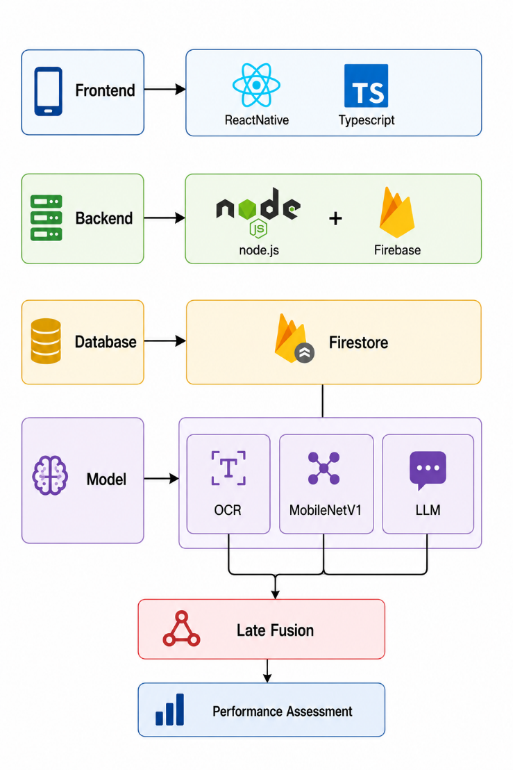
Figure 1: Flowchart of Tools & Technologies

CHAPTER 3
METHODOLOGY

Frontend Ecosystem
- ReactNative: React Native is an open-source software which assists in developing applications for multiple platforms using JavaScript and native components. Regarding the DSAISS app, React Native will be used to develop an easy-to-navigate mobile app interface to analyze and diagnose users' skin and recommend skin care measures. Navigation from one feature to another, such as scanning an image, skin care products recommendations, chatbot capabilities, and scheduling tasks, among others, will be made possible with React Native.
- Typescript: TypeScript programming language is statically typed and provides added features to JavaScript, such as static type checking and improved developer productivity. TypeScript will be utilized in this project to make coding more efficient and high-quality. This programming language ensures that errors are detected beforehand, thereby improving reliability. Besides, this programming language also improves code readability and helps develop features such as artificial intelligence and user authentication.

3.1.2 Backend Services
- Node.js: Node.js is a software environment where JavaScript code executes on the server-side instead of within a web browser environment. This has been accomplished via the use of the V8 JavaScript engine in Chrome. This software is very fast. The Node.js software is used in many applications in the development of back-end systems and APIs.
- Firebase: Firebase is a cloud-based system which makes possible the provision of various backend services for the development of mobile or web applications. Firebase plays a major role in providing services such as user authentication, data storage security, and cloud connections. Firebase assists in providing an easy interface between the application and the various backend services provided by Firebase.

3.1.3 Database & Cloud Storage
- Firestore: Through using Firebase, Firestore, and Authentication, it is possible to build applications back-end simply and securely. Firestore is a very scalable and available cloud database provided by Google that can be used for storing and synchronizing data in real time. It helps in securing user emails, passwords, and their other personal information. Firestore is the Firebase NoSQL database that holds application data. Firestore offers data synchronization in real time; thus, users will have access to up-to-date data instantly.
- Google Cloud: Google Cloud is considered as one of the best platforms that provides different services for creating scalable applications in the cloud computing domain. It has powerful infrastructure including virtual machines, storage, databases, and networking. It also supports machine learning and data analytics. The efficient performance of applications can be ensured through the use of Google Cloud with utmost security and worldwide availability.
CHAPTER 3
METHODOLOGY
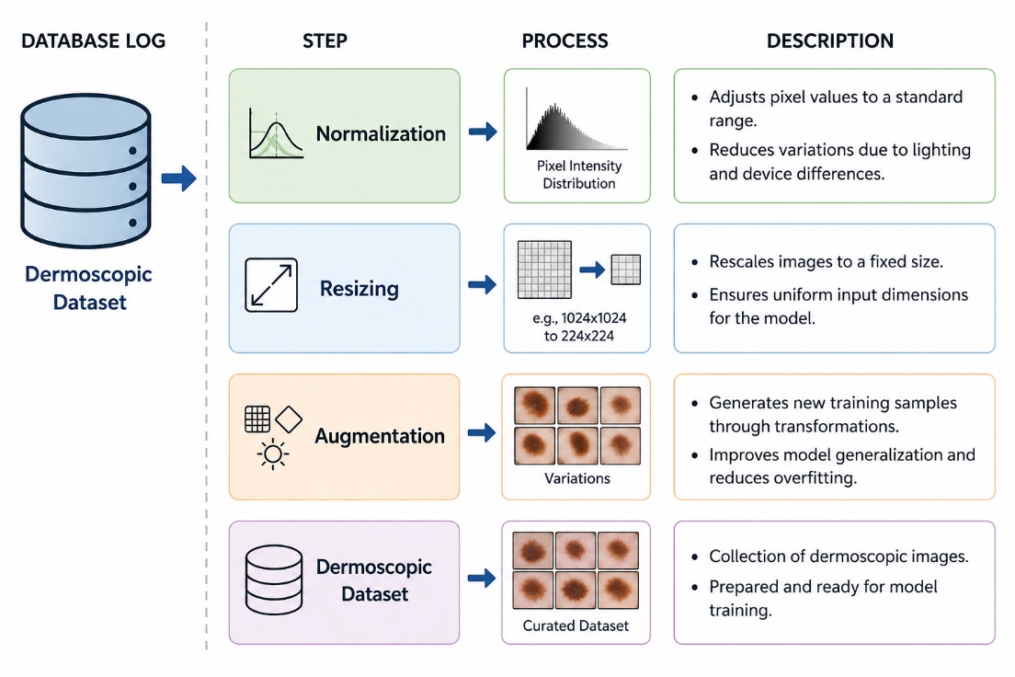
Figure 2: Flowchart of Data Cleaning

3.1.4 Data Collection
For this project, multiple datasets were collected from different websites for instance Kaggle, RoboFlow etc. These datasets are used for skin disease detection and analysis. The skin datasets consist of smartphone captured and dermoscopic skin image. These datasets form the foundation for image. The dataset we have collected after research articles, covers six skin diseases which are Acne, Benign Tumor, Eczema, Lichen, Scabies and Vitiligo etc.

3.1.5 Data Preprocessing
All the datasets go through some vital preprocessing steps before the model training phase to ensure the consistency of datasets and improved model performance.
- Resizing: All images are resized to a fixed resolution therefore the deep learning models can uniformly process them for instance CNNs. This process reduces the cost of computational expenses and also have an assure compatibility throughout the models.
- Normalization: Pixels values of images are normalized to a standard range, which create the balance and speed up the training process. The process of normalization also improves convergence during model optimization.
- Augmentation: To diversify the dataset and prevent over-fitting, there will be certain techniques referred to as augmentation techniques, which include rotations, flips, zooming, and adjustments to brightness that will be used. These techniques aid the model in generalizing itself for real-world skin pictures taken in various conditions.
CHAPTER 3
METHODOLOGY

3.1.6 Model Use
The system may integrate with three different model and each model has a specific purpose:
- OCR Model: OCR optical character recognition is the model used to recognize ingredients written in the text form from cosmetic products image taken using a smartphone. The text data obtained from the picture is converted into computer-readable data.
- MobileNetV1 CNN: The MobileNetV1 CNN is used for skin disease classification. It analyzes the segmented skin regions and predicts skin conditions or disease categories with higher accuracy.
- LLM Model: LLM is the model that interacts with the chatbot. Thus, it enables users to hold conversations and receive responses to their skincare queries. It becomes easy to provide explanations for model predictions in human-understandable language. The chatbot with LLM is able to respond to many questions related to the skincare topic. Also, it gives recommendations considering the analysis of the user’s skin.

3.1.7 Late Fusion
Late fusion strategy is utilized to integrate the outputs obtained from two models, which are image-based models like MobileNetV1 and EfficientNetV1. It should be noted that late fusion integrates decisions made by the models, not inputs fed into the models.

3.1.8 Performance Assessment
Finally, the DSAISS system’s performance is analyzed based on some standard criteria like accuracy and precision. This will help to determine the efficiency of the process of detection of skin diseases and analysis of ingredients used for products.

3.2 System Requirements

3.2.1 Functional Requirements
The functional requirements indicate the key operations and functionalities that DSAISS will undertake to provide solutions to the users. The requirements entail the processes involved in taking images of the skin, analyzing such images by the use of artificial intelligence (AI), detection of skin types through quiz, analysis of ingredients of skincare products, and recommending skincare products to users.
CHAPTER 3
METHODOLOGY
Table 2: Functional Requirements
S. No. | Functional Requirements |  |  | Type | Status
FR1 | The system permits user to sign up or log into their account before using the application for security purposes. |  |  | User | Completed
FR2 | The system will permit users to take or upload skin images directly from their phone for analyzing skin diseases. |  |  | User | Completed
FR3 |  | The system will permit users to answer the quiz to determine skin types. | User |  | Completed
FR4 |  | The application will provide customized advice for skincare, diet, and product recommendations according to the skin condition and type detected. | System |  | Completed
FR5 |  | A smart ingredient scanner powered by Optical Character Recognition and LLM Model that will allow users to verify the suitability of the skincare products and warn them against irritants and dangerous ingredients. | System |  | Completed
FR6 |  | Using the weather data for skin advice from the OpenWeatherMap API, the users would be reminded daily about their skin care needs like applying sunscreen when there is higher UV index or applying moisturizer when the weather is dry. | System |  | Completed
FR7 |  | All scanned data and information will be safely stored in Firebase Firestore and Google Cloud. | System |  | Completed
FR8 |  | The Skin Care Assistant allows users to interact with the system in natural language and get instant results. It provides 24/7 AI-based assistance for user queries and guidance. | System |  | Completed
FR9 |  | The system also offers a functionality by name of Skin Routine Schedular that will notify and remind morning and night routine that will enable users to maintain regular and healthy skin care regime. | System |  | Completed
FR10 |  | Streaks is an efficient method when used to monitor the frequency of practicing skincare routines by people. It is also effective in helping people practice their skincare daily and ensure that they observe healthy skincare practices. | System |  | Completed
CHAPTER 3
METHODOLOGY

3.2.2 Non-Functional Requirements
The non-functional requirements are the standards that the performance of DSAISS must meet. The non-functional requirements set out the speed at which the AI’s predictions should run; its level of security, reliability, and portability across all sorts of devices, including but not limited to computers. Non-functional requirements also relate to such things as scalability, maintainability, precision, and usability.
Table 3: Non-Functional Requirements
S. No. | Non-Functional Requirements |  | Category
NFR1 | The proposed system, DSAISS, guarantees efficient processing, with image analysis, skin disease prediction, skin type detection, and ingredient scanning results being generated in 3-6 seconds through TensorFlow Lite models. |  | Performance
NFR2 | All user information and scan results will be secured through the use of Firebase Firestore security rules and encryption. | Security
NFR3 | The system shall remain available 24/7 with minimal downtime, ensuring continuous access to scanning and notification features | Availability
NFR4 | The system shall support proliferating number of user, images, notifications and scan id’s without effecting performance, by using Firebase cloud services. | Scalability
NFR5 | The system shall maintain high prediction accuracy by using a trained AI model, reliable skin type quiz logic, and verified ingredient detection. | Accuracy

3.3 Methodology

3.3.1 Use-Case Diagram
The use case diagram highlights the relationship between the user and the system through the various functionalities in the system. The use case diagram helps determine the key actors in the system and their actions in the system. For instance, in the DSAISS project, the use case diagram shows how users upload their skin images, analyze the images, and view the predicted result. This diagram helps in clearly defining system requirements and user expectations.

CHAPTER 3
METHODOLOGY
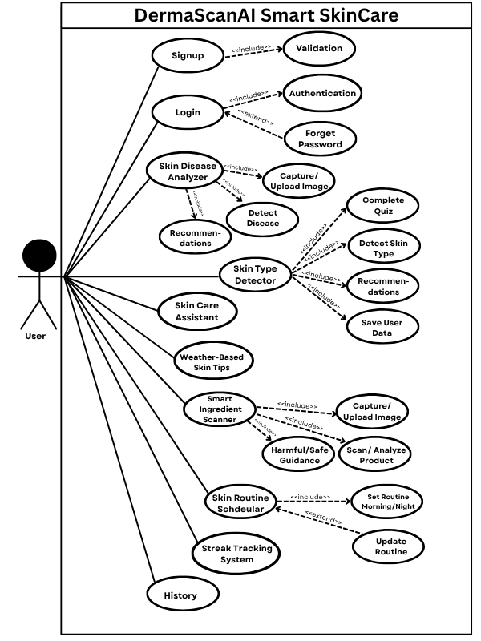
Figure 3: Use Case diagram
CHAPTER 3
METHODOLOGY
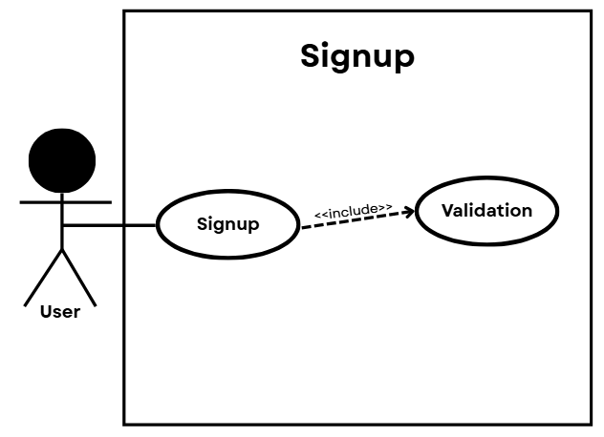
Figure 4: Signup Use Case
Table 4: UC01 Signup
Use Case ID: | UC01
Use Case Name: | Signup
Created By: | Fatima Iqbal | Last Updated By: |  | Fatima Iqbal
Created Date: | 4th November,2025 | Last Revision Date: |  | 9th November,2025
Actors: | User
Description: | User create an account to accessing application, and system validates the entered information before completing signup.
Trigger: | The User clicks on "Sign Up" to create an account.
Precondition: | The user has not registered before, user has access to the signup page, and the system is operational.
Post Condition: | A new user account is created successfully, and the user info is stored in the database, after which the user logs into their newly-created account.
Normal Flow: | Actor |  | System
Normal Flow: | - User opens the signup page.  - User enters required details.  - User clicks the Signup button. |  | - System includes Validation to check the entered data.  - If validation is successful, the account is created.
Alternative Flow: | Email already exists: If the user provides an email that is already registered, the system will display an error message ("Email already in use").
Exceptional Scenario: | In case the inputted info is wrong, the system displays an error message. Signup is not done in case the email is duplicated.

CHAPTER 3
METHODOLOGY
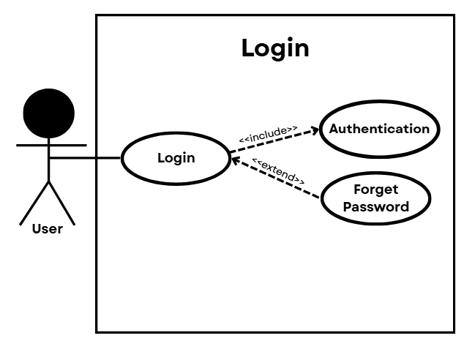
Figure 5: Login Use Case
Table 5: UC02 Login
Use Case ID: | UC02
Use Case Name: | Login
Created By: | Fatima Iqbal | Last Updated By: |  | Momina Aftab
Created Date: | 4th November,2025 | Last Revision Date: |  | 9th November,2025
Actors: | User
Description: | User create an account to accessing application, and system validates the entered information before completing signup.
Trigger: | Patient user clicks on the “Log In” button to gain entry into the platform.
Precondition: | The user is not registered in the system; the user has the access privilege to sign up; the system is operational and connected to the database.
Post Condition: | A new user account is successfully created, and user information is saved in the database, then user can proceed to login using the registered credentials.
Normal Flow: | Actor |  | System
Normal Flow: | - User opens the login page.  - User enters email and password.  - User clicks the login button. |  | - System includes authentication to check the entered data.  - If authentication is successful, the account is login.
Alternative Flow: | Invalid credentials: When the user inputs invalid credentials, the system generates an “Invalid credentials” message prompting the user to log in with valid credentials.
Exceptional Scenario: | In case of invalid inputted data, an error message is generated by the system. In case the email address is already registered, the user cannot complete the signup process.
CHAPTER 3
METHODOLOGY
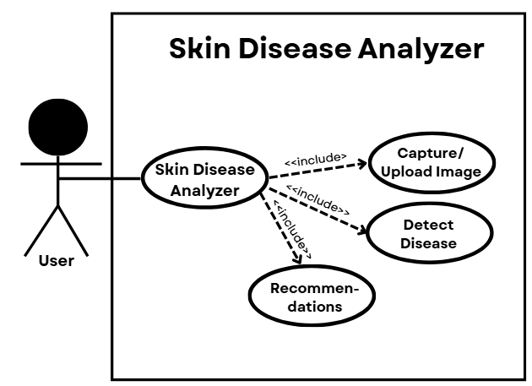
Figure 6: Skin Disease Analyzer Use Case
Table 6: UC03 Skin Disease Analyzer
Use Case ID: | UC03
Use Case Name: | Skin Disease Analyzer
Created By: | Iqra Pervez | Last Updated By: |  | Momina Aftab
Created Date: | 1st February,2026 | Last Revision Date: |  | 16th April,2026
Actors: | User
Description: | In this use case, the user can diagnose the skin disease with the help of uploading images. In the next step, the software will analyze the image and provide the results of diseases. Moreover, it will show suggestions and advice for the users.
Trigger: | The user selects the “Skin Disease Analyzer” feature and uploads or captures a skin image for analysis.
Precondition: | User is logged in into the system and feature of disease detection is accessible by him/her.
Post Condition: | Disease detection result is shown.
Normal Flow: | Actor |  | System
Normal Flow: | - User opens the Skin Disease Analyzer feature.  - User captures or uploads an image of his/her skin. |  | - System will Detect Disease to analyze the image.  - System then provide some recommendations and Tips based on the detected disease.  - System displays the disease result to the user.
Alternative Flow: | In case the uploaded image does not meet these requirements, the error message will be displayed on the screen prompting users to provide a valid image of skin.
Exceptional Scenario: | In case of invalid or blurry image, or non-relevant skin images, the system will display an error message to the user and will ask to upload a new image.
CHAPTER 3
METHODOLOGY
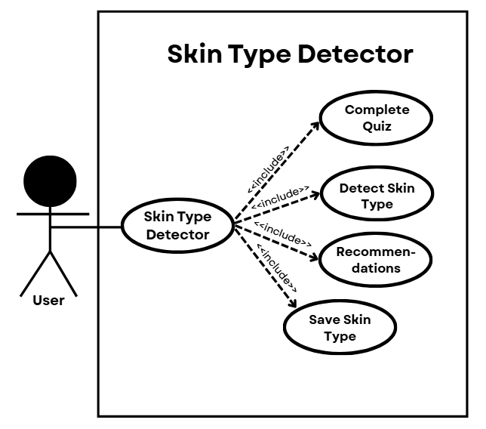
Figure 7: Skin Type Detector Use Case
Table 7: UC04 Skin Type Detector
Use Case ID: | UC04
Use Case Name: | Skin Type Detector
Created By: | Momina Aftab | Last Updated By: |  | Iqra Pervez
Created Date: | 1st December,2025 | Last Revision Date: |  | 5th April,2026
Actors: | User
Description: | In this use case, the user is able to detect their skin type using a quiz that the system offers.
Trigger: | The user picks “Skin Type Detector” functionality and begins the process of answering questions about skin types.
Precondition: | User is logged into the system and “Skin Type Detector” feature is available.
Post Condition: | Skin type is successfully identified and data is saved for future reference.
Normal Flow: | Actor |  | System
Normal Flow: | - User opens the Skin Type Detector feature.  - User completes 12 mention quiz in that screen. |  | - System detects skin type based on quiz answers.  - System shows recommendations for the detected skin type.  - System saves skin type data in the system.
Alternative Flow: | In case the user does not answer some quiz questions, the system alerts him that he should answer all questions before skin type detection begins.
Exceptional Scenario: | In case there is an issue with the quiz answer submission or processing, the system shows an error message.
CHAPTER 3
METHODOLOGY
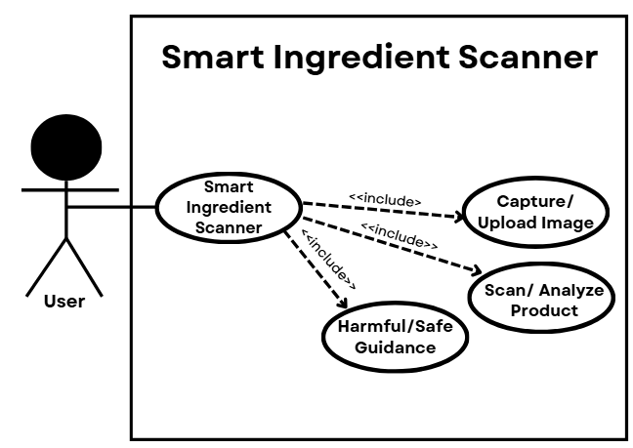
Figure 8: Smart Ingredient Scanner Use Case
Table 8: UC05 Smart Ingredient Scanner
Use Case ID: | UC05
Use Case Name: | Smart Ingredient Scanner
Created By: | Fatima Iqbal | Last Updated By: |  | Fatima Iqbal
Created Date: | 1st November,2025 | Last Revision Date: |  | 9th April,2026
Actors: | User
Description: | In this usecase, user to scan a skincare product to check whether it is safe or harmful for their skin. The system analyzes ingredients, provides recommendations.
Trigger: | The user selects the “Smart Ingredient Scanner” feature and uploads or captures a skincare product image for analysis.
Precondition: | User is logged into the system and “Smart Ingredient Scanner” feature is available.
Post Condition: | Product safety result is shown.
Normal Flow: | Actor |  | System
Normal Flow: | - User opens the Smart Ingredient scanner feature.  - User capture or upload image or write text of ingredients. |  | - System includes ingredient analysis.  - System includes recommendations and tips based on the analysis.  - System displays the product safety result.
Alternative Flow: | If the uploaded image is unclear or ingredient text is not readable, the system interrogate the user to upload a clearer picture again.
Exceptional Scenario: | Should there be an unsuccessful attempt at detecting or analyzing the ingredients for any reason, an error notification will be provided, and the scanning will not take place.

CHAPTER 3
METHODOLOGY
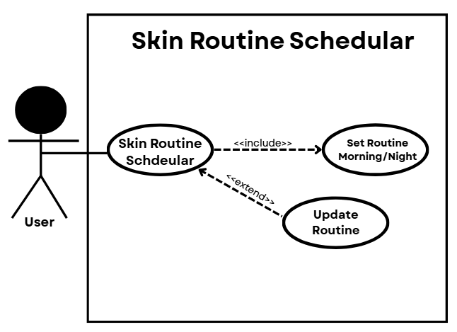
Figure 9: Skin Routine Schedular Use Case
Table 9: UC06 Skin Routine Schedular
Use Case ID: | UC06
Use Case Name: | Skin Routine Schedular
Created By: | Momina Aftab | Last Updated By: |  | Iqra Pervez
Created Date: | 1st November,2025 | Last Revision Date: |  | 9th April,2026
Actors: | User
Description: | In this case, a user has the ability to obtain and organize daily skin care program, while the system generates morning and evening skin care programs.
Trigger: | The user selects the “Skin Routine Scheduler” feature to create or manage a skincare routine.
Precondition: | User is logged into the system.
Post Condition: | Skin routine is created and saved then user can view and follow the routine daily.
Normal Flow: | Actor |  | System
Normal Flow: | - User opens the Skin Routine Scheduler feature.  - User set morning/night reminders manually. |  | - System includes generating skin routine morning or night.  - System may send routine reminders.
Alternative Flow: | If the user does not set reminders, the system still generates and saves the skincare routine without reminder notifications.
Exceptional Scenario: | If the reminder or notification service fails, the system still displays and saves the skincare routine for the user.

CHAPTER 3
METHODOLOGY
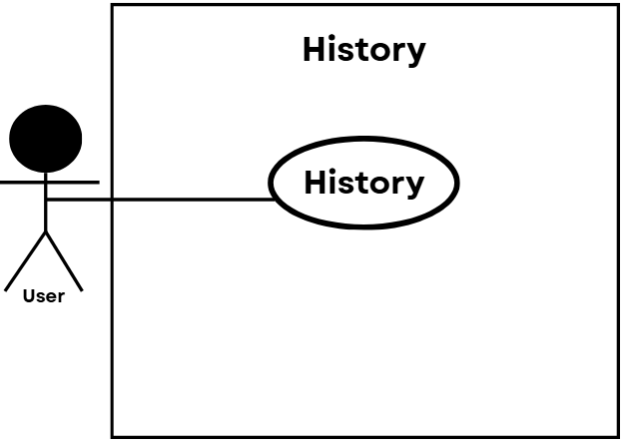
Figure 10: History Use Case
Table 10: UC07 History
Use Case ID: | UC07
Use Case Name: | History
Created By: | Momina Aftab | Last Updated By: |  | Momina Aftab
Created Date: | 1st January,2026 | Last Revision Date: |  | 5th April,2026
Actors: | User
Description: | In this use case, the user will be able to see his/her previous records for skin type analysis whether it be combination, oily, or any other skin type.
Trigger: | The user chooses the “History” function to see past records for skin type analysis.
Precondition: | User has logged into the system and has previous records of skin analysis.
Post Condition: | Selected history data is displayed successfully and user can review past results about their skin type.
Normal Flow: | Actor |  | System
Normal Flow: | - User opens the History feature. |  | - The system displays the skin type results.
Alternative Flow: | When there is no recorded history before that time, then the system shows a “Begin New Assessment” message.
Exceptional Scenario: | If there is any problem with the database, then it shows an error message and does not display any history at all.

CHAPTER 3
METHODOLOGY
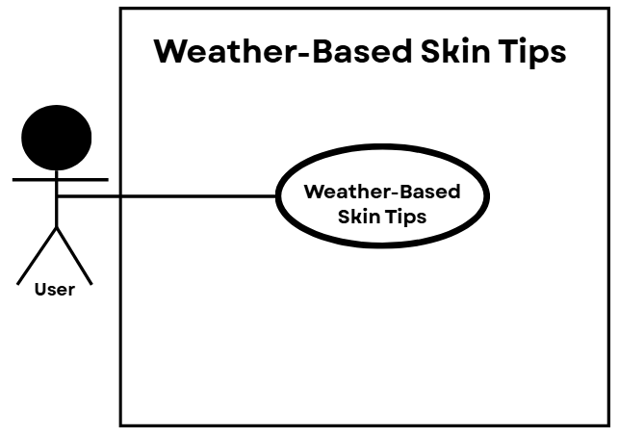
Figure 11: Weather-Based Skin Tips Use Case
Table 11: UC08 Weather-Based Skin Tips
Use Case ID: | UC08
Use Case Name: | Weather-Based Skin Tips
Created By: | Iqra Pervez |  | Last Updated By: | Iqra Pervez
Created Date: | 1st December,2025 |  | Last Revision Date: | 8th April,2026
Actors: | User
Description: | This use case allows the user to receive skincare tips according to current weather conditions such as humidity, temperature, sunlight, or dryness.
Trigger: | The user opens the “Weather-Based Skin Tips” feature to view skincare advice according to weather conditions.
Precondition: | The user has logged into the system, and both internet and weather services are available.
Post Condition: | Weather-based skincare tips will display successfully to the user.
Normal Flow: | Actor | System
Normal Flow: | - User opens the Weather Based Skin Tips. | - System fetches current weather information.  - System analyzes weather conditions.  - System generates skincare tips based on the weather.  - System displays weather-based skincare recommendations to the user.
Alternative Flow: | In case live weather information is unavailable, the application shows general skin care tips without mentioning anything regarding weather information.
Exceptional Scenario: | In case there are no live weather services, then an error message is displayed on the screen, and no weather tips are shown.

CHAPTER 3
METHODOLOGY
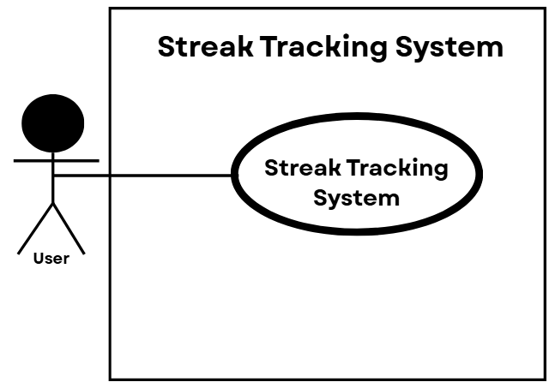
Figure 12: Streak Tracking System Use Case
Table 12: UC09 Streak Tracking System
Use Case ID: | UC09
Use Case Name: | Streak Tracking System
Created By: | Fatima Iqbal | Last Updated By: |  | Fatima Iqbal
Created Date: | 1st March,2026 | Last Revision Date: |  | 4th April,2026
Actors: | User
Description: | This use case enables the user to keep track of their skincare routine streak. The system keeps updating the streak based on the user's behavior.
Trigger: | The user completes a daily skincare activity in the app.
Precondition: | The user has logged in to the system, and the streak tracking system is turned on.
Post Condition: | User streak count in system successfully.
Normal Flow: | Actor |  | System
Normal Flow: | - User complete morning/night skin care routine and daily check-in. |  | - System records the activity.  - System updates the streak count process then.  - System also displays the updated streak progress to the user.
Alternative Flow: | In case the user fails to do the daily check-ins, there is no increment in the streak counter, and the current streak remains the same.
Exceptional Scenario: | If the system fails to load the streak data, an error will be generated.

CHAPTER 3
METHODOLOGY
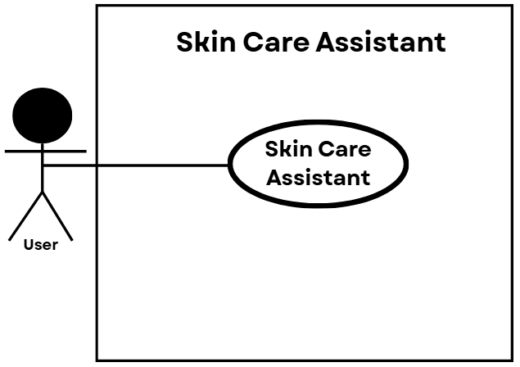
Figure 13: Skin Care Assistant Use Case
Table 13:UC10 Skin Care Assistant
Use Case ID: | UC10
Use Case Name: | Skin Care Assistant
Created By: | Iqra Pervez | Last Updated By: |  | Fatima Iqbal
Created Date: | 1st March,2026 | Last Revision Date: |  | 1st May,2026
Actors: | User
Description: | The main aim behind this use case is to make possible for the users to communicate with the artificial intelligence based skincare assistant which provides information as well as advice regarding their skin care needs.
Trigger: | The user opens the “Skin Care Assistant” feature or sends a skincare-related query in the chat interface.
Precondition: | User is logged into the system and Skin Care Assistant feature is available.
Post Condition: | User receives an AI-generated response with skincare advice or information.
Normal Flow: | Actor |  | System
Normal Flow: |  |  | - The System interprets the queries by utilizing an AI model.  - The System produces a proper answer or suggestion for the user.
  - User opens the Skincare Assistant.
  - The User gives certain queries about his/her skin.
Alternative Flow: | In case the question from the user is not clear, the system prompts the user to clarify the input.
Exceptional Scenario: | In case the AI software or the processing system malfunctions, the system shows an error message and fails to generate a response.

CHAPTER 3
METHODOLOGY

3.3.2 Sequence Diagram
The sequence diagram portrays the communication of various components within the system in a temporal fashion. The messages that occur among the user, application interface, AI model, and database can be captured by the sequence diagram. In DSAISS, the sequence diagram depicts the process of the image upload, skin disease detection through an AI analysis, and result retrieval. Furthermore, requests for product and routine recommendation can be observed through this diagram. This diagram helps in understanding system flow, component communication, and response order during AI based skin analysis. The following sequence diagram illustrates the sequence of login and registration processes.
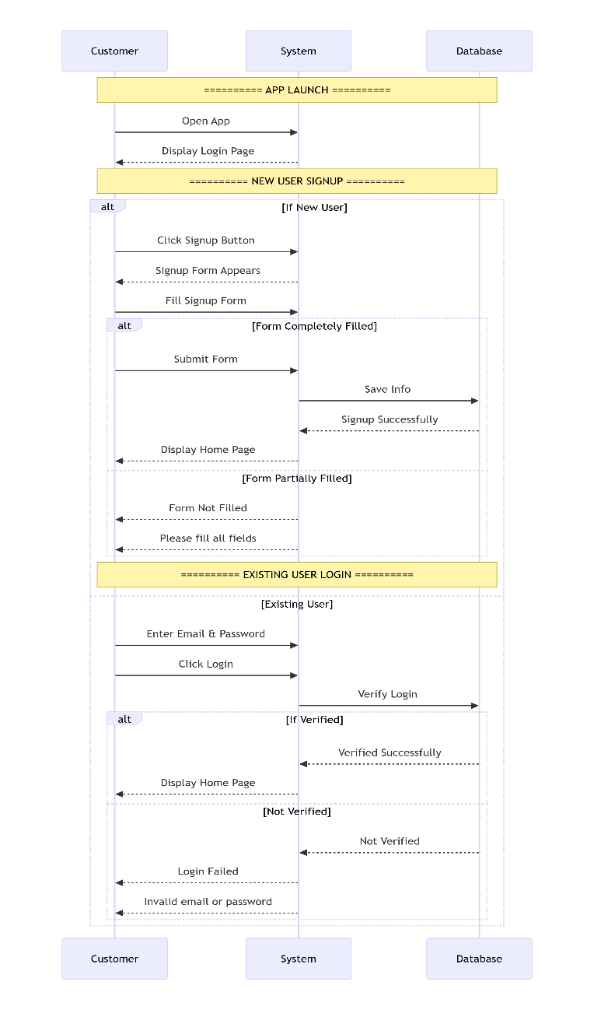
Figure 14: Sequence Diagram-1
CHAPTER 3
METHODOLOGY
The following sequence diagram illustrates the sequence of menu or drawer navigation.
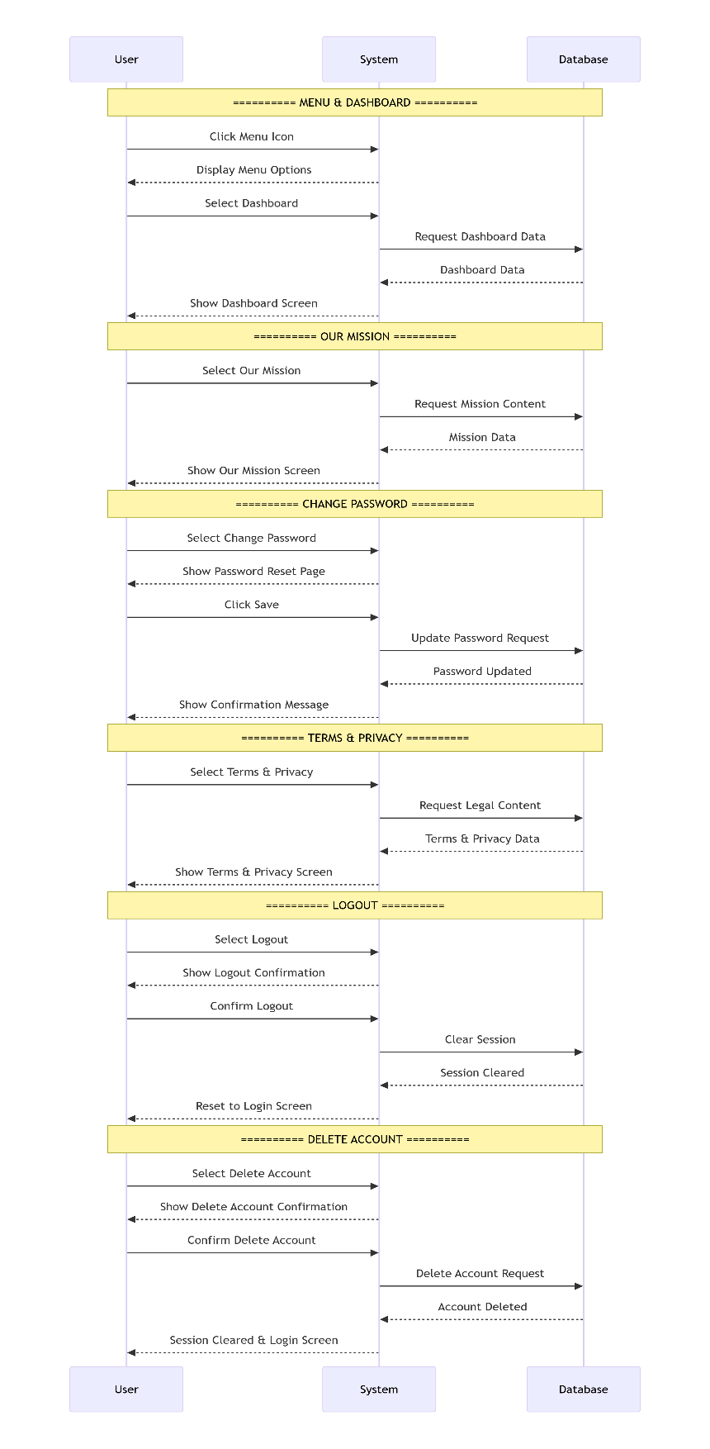
Figure 15: Sequence Diagram-2
CHAPTER 3
METHODOLOGY
In this sequence diagram, the sequence of main features is illustrated. Main features are discussed on the main page of the app, such as detection of disease, skin type, and product ingredients scanner.
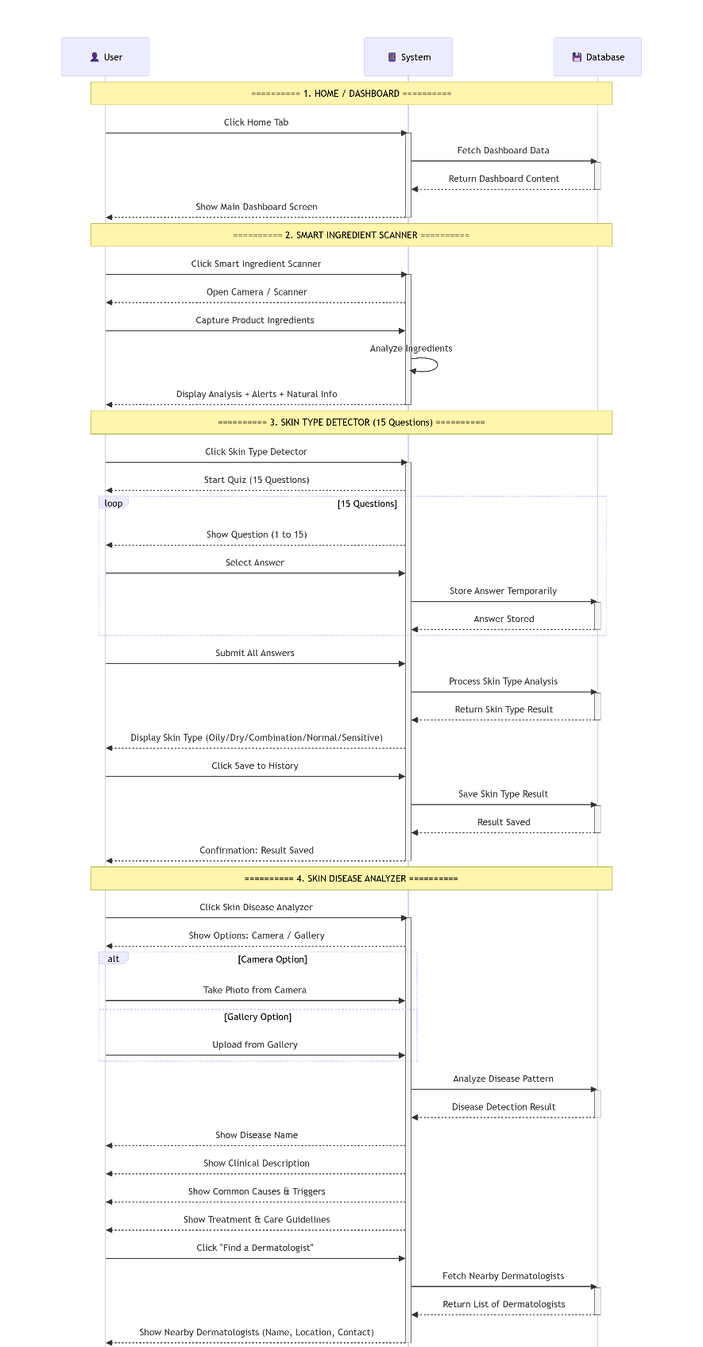
Figure 16: Sequence Diagram-3
CHAPTER 3
METHODOLOGY
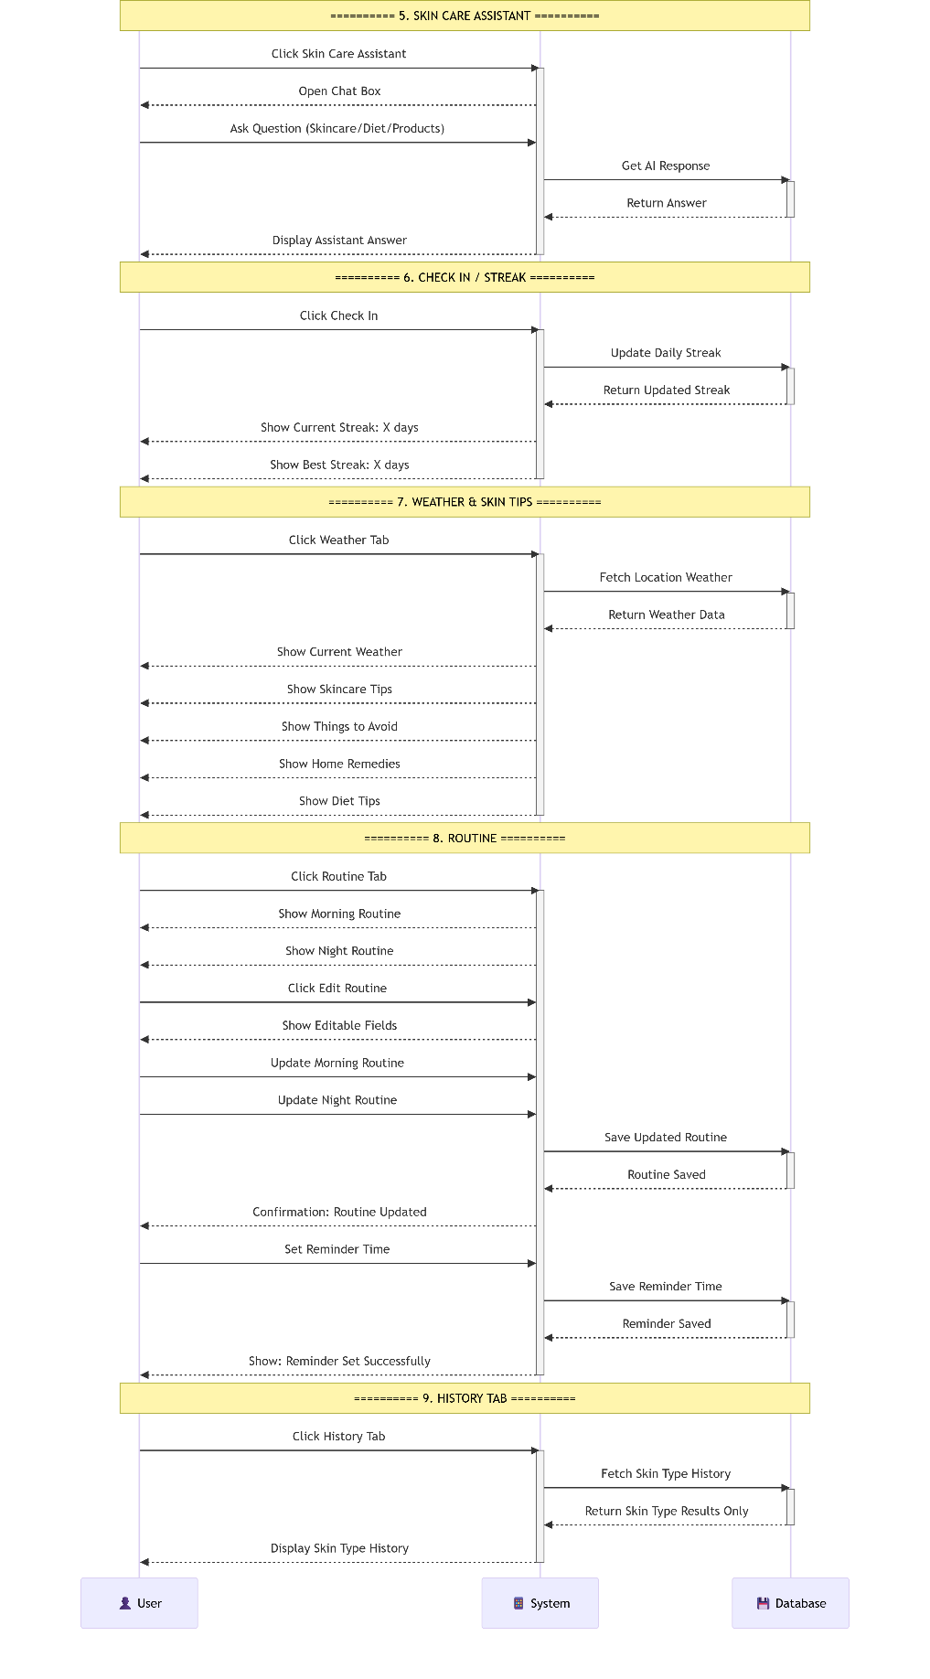
Figure 17: Sequence Diagram-4
CHAPTER 3
METHODOLOGY

3.3.3 Activity Diagram
An activity diagram is a kind of diagram that displays the sequence of activities, choices, and processes that take place in a system from start to finish. It helps visualize how different activities happen and how control moves between them. The activity diagram in DSAISS describes all the steps involved, starting with the upload of the images to predicting skin disorders. It describes how the system interacts with the image, analyses it using the artificial intelligence system, and gives the results of its diagnosis.
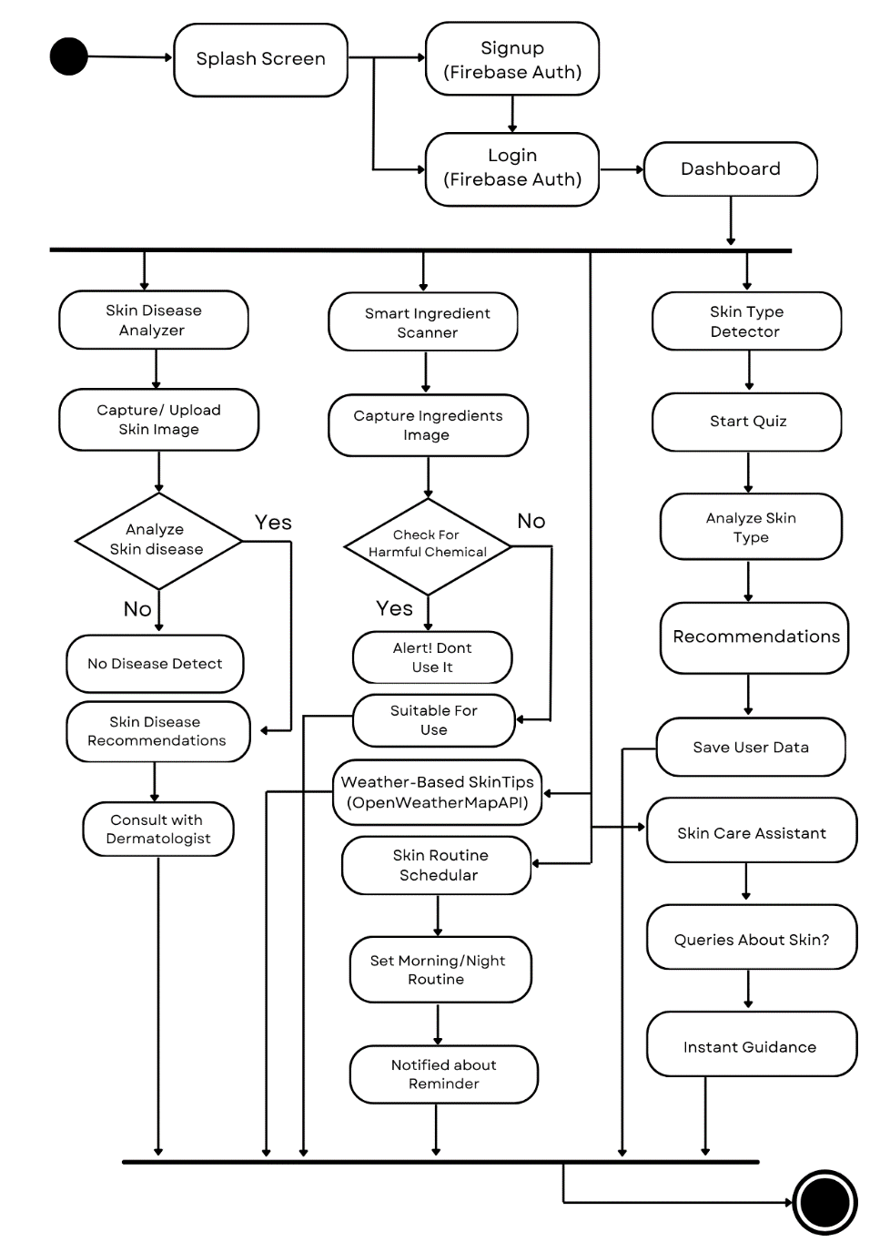
Figure 18: Activity Diagram
CHAPTER 3
METHODOLOGY

3.3.4 ER-Diagram
An ER entity relationship diagram can be defined as a diagram used to represent the structure of data in a system in relation to entities, attributes, and relationships. It assists in understanding the manner in which the data is structured in the system. In the DSAISS project, an ER diagram for the entities such as the user, skin image, diagnosis result, and report. The relationship exists between the user and the images loaded along with the results of the analyses performed.
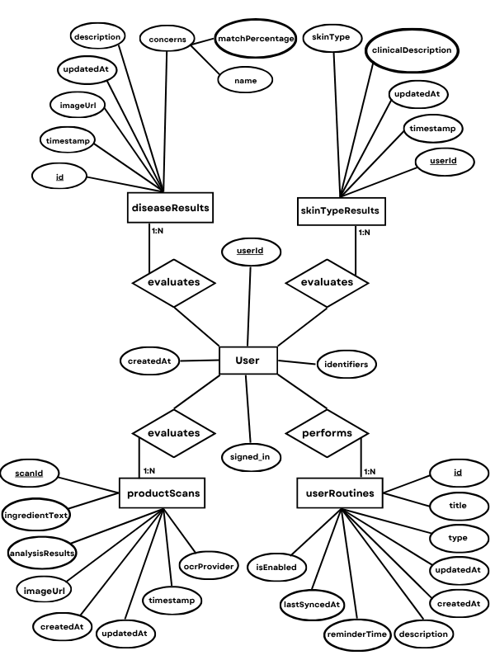
Figure 19: ER Diagram

CHAPTER 4
IMPLEMENTATION
In this chapter we show the way our DSAISS project works in practice. We present the actual implementation of our project using application user interface screenshots. The pictures presented here demonstrate the important screens of the application that show how the users use different features and functionalities. Every screen corresponds to particular functionality of the modules such as skin analysis, ingredient scanning of products, visualization of results, and routine schedular. The brief explanation is provided for each picture describing their purpose in the application.

4.1 User Interfaces
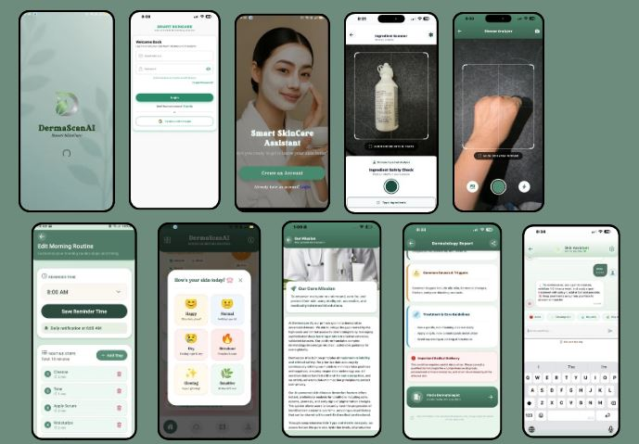
Figure 20: User Interfaces
CHAPTER 4
IMPLEMENTATION
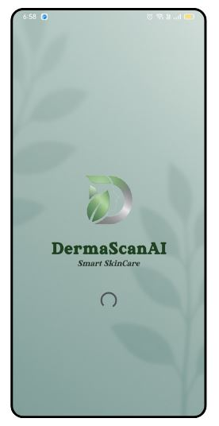
Figure 21: Splash Screen
This is Splash Screen that interact with user, with light green theme and it takes 3 seconds loading to navigate to next screen. That gives user-friendly interface look.
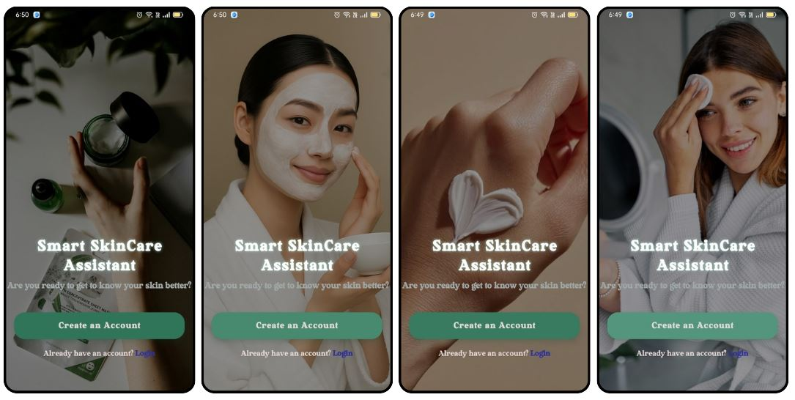
Figure 22: Splash Screen 2
This is the splash screen, where user have to create an account or login his account to access the application. This screen shows multiple images at background with smooth animation, which gives an attractive look to interact with a user in an efficient manner.

CHAPTER 4
IMPLEMENTATION

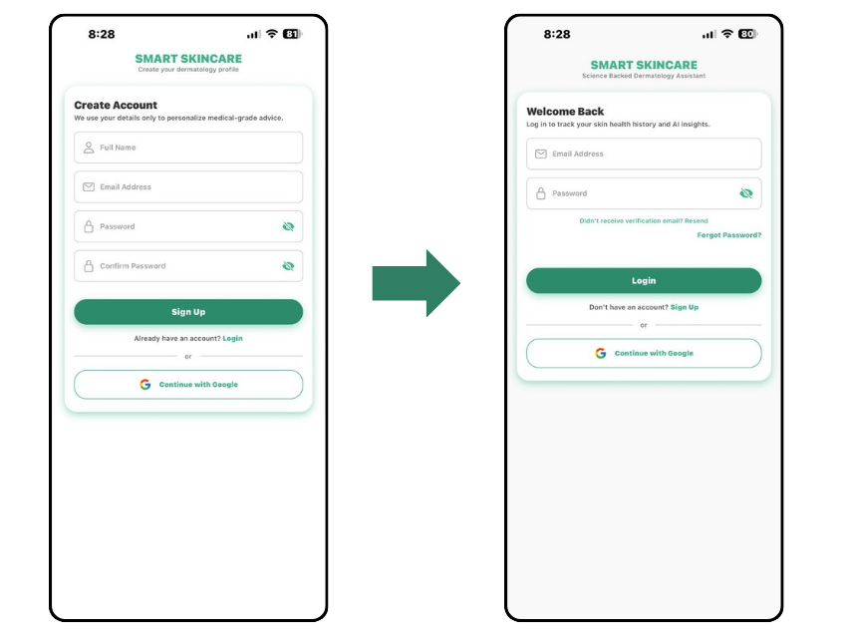
Figure 23: Login & Signup Screen
In this image Signup Screen, where user have to register his account with validations, and insert their name, email, and password. After it, user navigates to Login screen where user have to Login his account, user should know that he had an existing account for login purpose, without an existing account user get an error message.
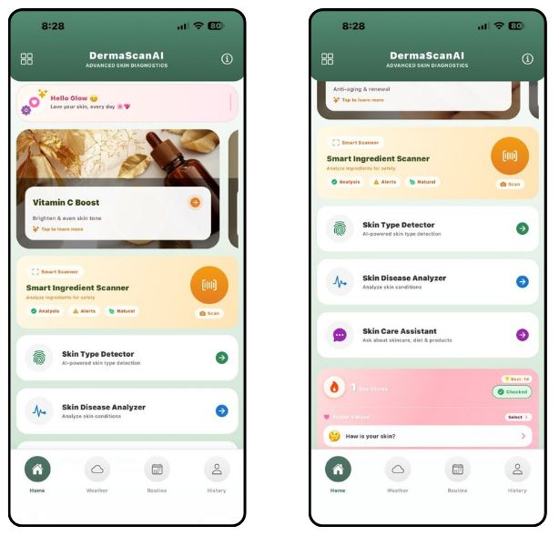
Figure 24: Dashboard Screen
This is the main dashboard screen, where user can select and access many features, like smart ingredient scanner, skin disease analyzer, skin type detector, skin routine schedular, skin care assistant, streak tracking system and weather-based skin tips.

CHAPTER 4
IMPLEMENTATION
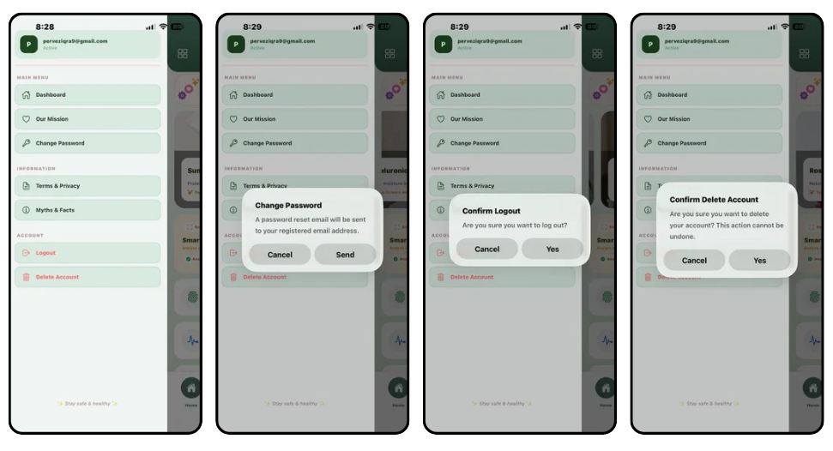
Figure 25: Drawer Navigation-1
This is drawer navigation screen, where user can change the password of his account, he can logout his account and also delete his account.
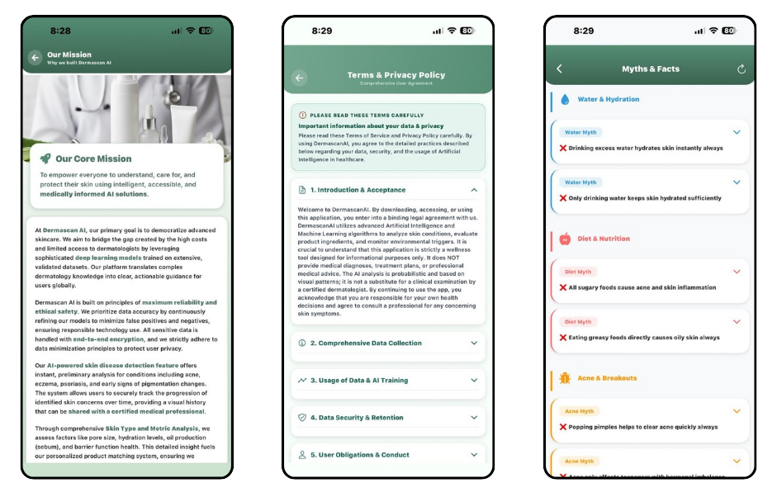
Figure 26: Drawer Navigation-2
This figure shows user can view our core mission of DSAISS, their term and policies, and also can view myths and facts about skin. Myths and facts change after reloading it.
CHAPTER 4
IMPLEMENTATION
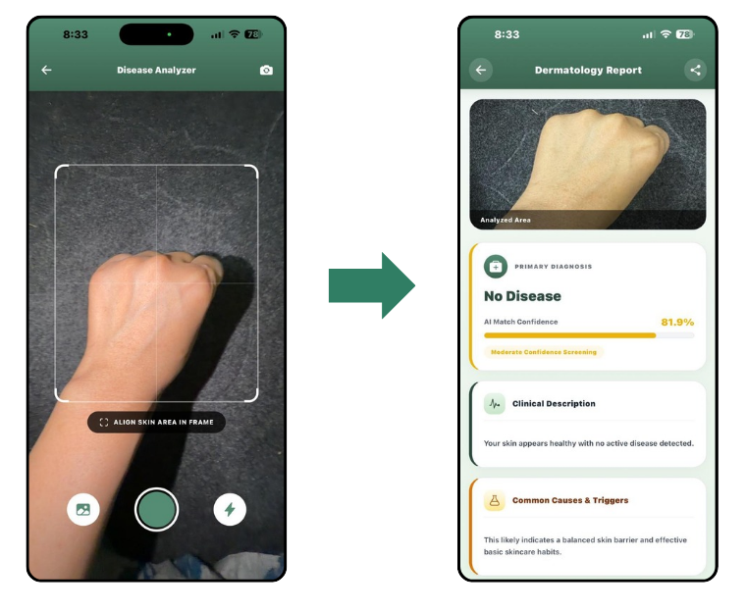
Figure 27: Skin Disease Analyzer Screen-1
This screen will allow user to capture or upload his skin picture for disease detection. This screen takes a bit time to detect disease, after few time it shows detected disease or shows that no disease detected.
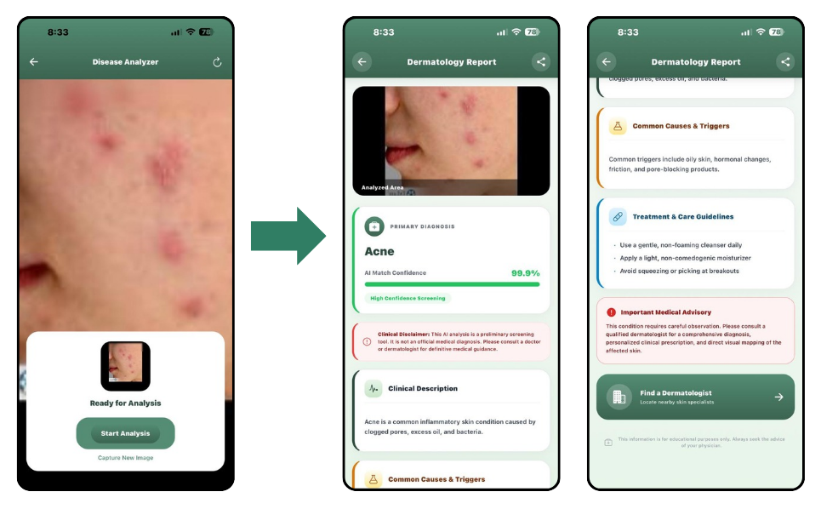
Figure 28: Skin Disease Analyzer Screen-2
This is the disease detection screen and user will click on the button Start Analysis to detect his skin disease. This screen shows the detected disease and recommendations and tips that user must have to follow for safety purpose, and make surety for their skin concerns.
CHAPTER 4
IMPLEMENTATION
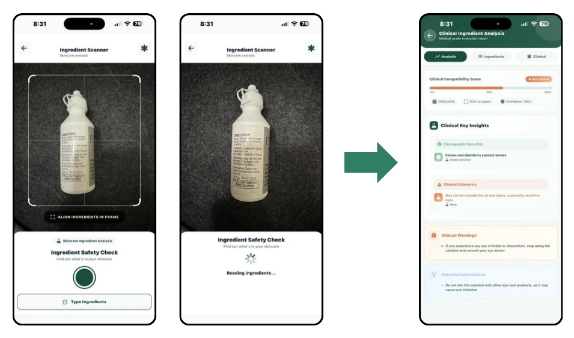
Figure 29: Smart Ingredient Scanner Screen
This figure shows that user can capture the image of ingredient and type manually as well. Last screen then shows the recommendations and effects of ingredient that you scanned, for instance ingredient is harmful or have a mild issue.
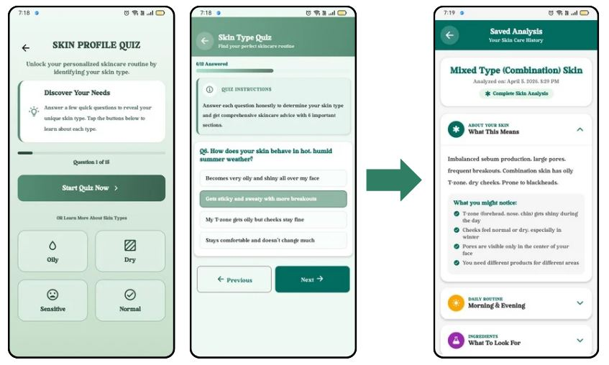
Figure 30: Skin Type Detector Screen
This is skin type detection screen, where user have an access to detected his skin type, that might be oily, sensitive, dry or normal. It allows user to complete 12 questions and then about skin. It takes a little time to analyzing skin type and then shows the result of detected skin type of user, and provides some recommendations and tips, screen allows user to recheck and complete his questions as well. This screen saves the result of detected skin type, where user have an access to recheck their skin type result.
CHAPTER 4
IMPLEMENTATION
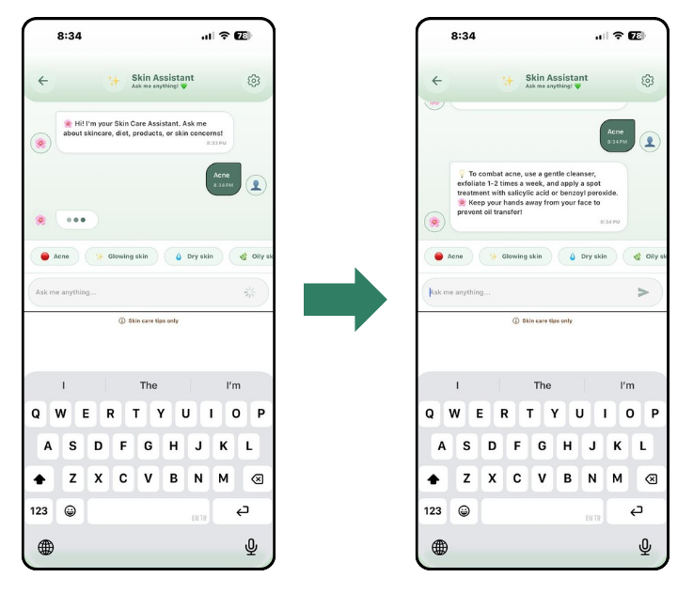
Figure 31: Skin Care Assistant Screen
This figure shows that user can interact with skin care assistant, by asking some guidance about skin. Skin care assistant shows an instant result to user.
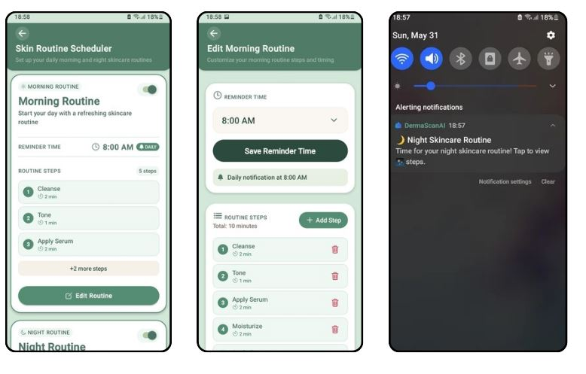
Figure 32: Skin Routine Schedular Screen
In this screen, user have an access to set the morning/night skin routine, that notify him to use this these products or anything on set time, user can add or set routine manually, by adding time or routine name.
CHAPTER 4
IMPLEMENTATION
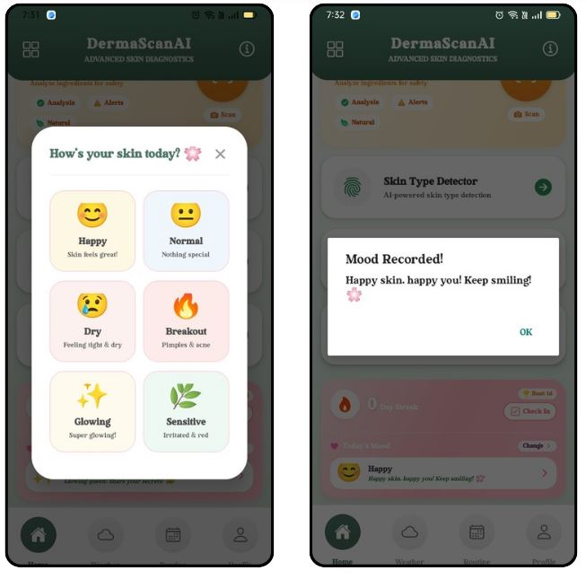
Figure 33: Streak Tracking System Screen
This figure shows user can set his mood and can change it after time, when user start streak system, it starts count down from onwards.
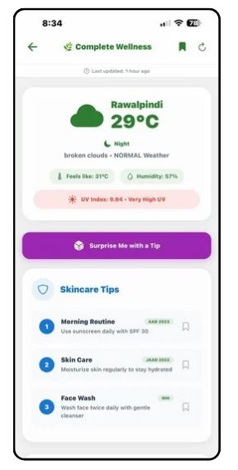
Figure 34: Weather-Based Skin Tips Screen
In this screen user can check the weather based tips or recommendations, by application, after fetchning weather, our application can recommend the products as well, for skincare.
CHAPTER 5
TESTING
In this chapter we are going to test the DSAISS system. We will test all its features. These features include signing up, logging in, detecting diseases, scanning products ingredients, detecting skin types, weather-based skin tips, and skin care assistant, skin routine schedular and streak tracking system. The goal of testing is to make sure each feature works right. We want to ensure that DSAISS gives results to the user in an efficient manner. We test how the system handles user inputs and check if it produces outputs, test each module separately. This helps us find any errors. We pay attention to AI predictions and recommendations and want to make sure they are accurate. Moreover, we perform testing of the user interface for making sure that it is user-friendly and functioning properly in all features. Generally, this chapter ensures the performance and reliability of the developed system.
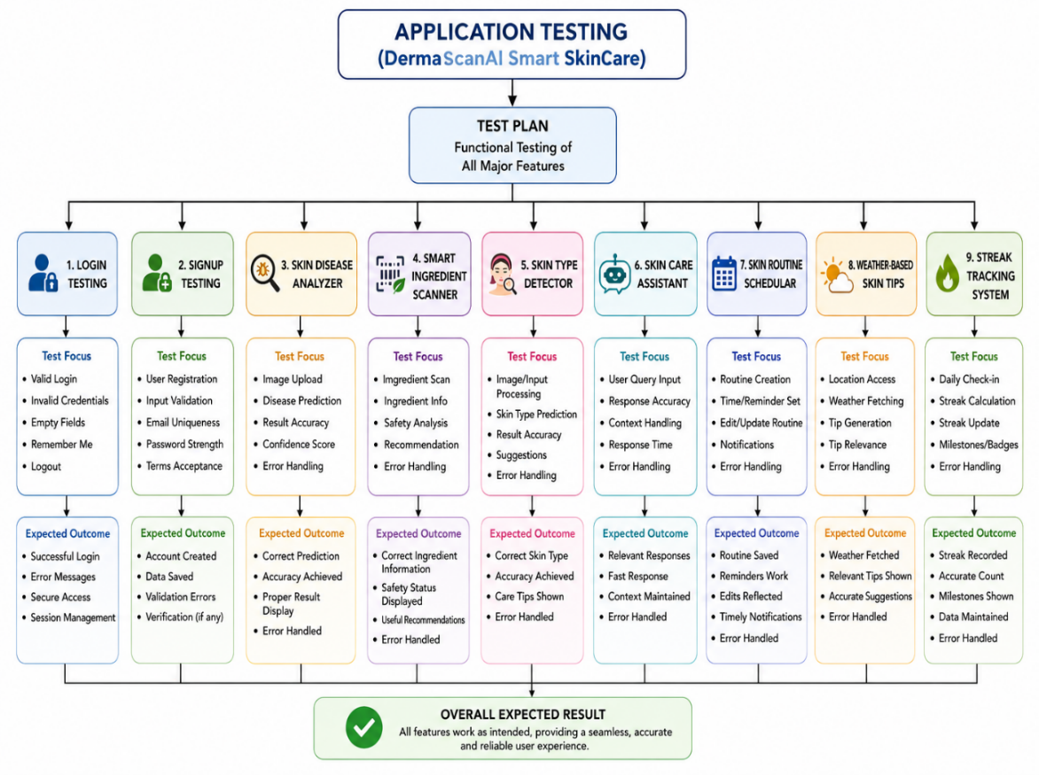
Figure 44: Flowchart of Testing Features
This flowchart shows the testing structure and how we checked different parts of the system during development. We tested to make sure it works well. The testing process checked if it works correctly is accurate handles errors well and ensures that our application works reliably and stable. We tested each part separately and system modules were evaluated properly.

CHAPTER 5
TESTING

5.1 User Signup
- Caption: Validate User’s ability to Sign up Successfully.
- Steps:
- Proceed to Sign up screen.
- Provide legitimate user information.
- Click on "Sign up" Button.
- Expected Result: User gets signed up successfully and redirects to the log-in page.
Table 14: Test Case 1 Signup
Module Name | User Signup
Test Case ID | DSAISS_01
Tester Name | DSAISS
Test Case Description | To audit Signup interoperability of DSAISS App.
Tester’s Name | Fatima Iqbal
Environmental Info | Android Mobile

Test Scenario | Determining whether the user is allowed to Sign up for the application.

Test Case ID | Test Steps | Test Input | Expected Results | Actual Results | Status | Comments
DSAISS_01 | Tap on “Create an Account” |  | Signup page appears. | As Expected | Pass | No issue found.
DSAISS_01 | Full Name | Fatima | Accepted | As Expected | Pass | No issue found.
DSAISS_01 | Email | dermascanai1166@gmail.com | Accepted | As Expected | Pass | No issue found.
DSAISS_01 | Password | Skin0@ | Accepted | As Expected | Pass | No issue found.
DSAISS_01 | Click on “Signup” button. |  | Navigate to Login page. | As Expected | Pass | No issue found.

CHAPTER 5
TESTING

5.2 User Signup-Negative Testing
- Caption: Verify that a user with invalid and incomplete data is not accepting during the registration.
- Steps:
- Navigate to Signup screen.
- Enter invalid and incomplete user details.
- Press the “Signup” button.
- Expected Results: User should not be register and error message should be shown.
Table 15: Test Case 2 Negative Signup
Module Name | Negative Signup
Test Case ID | DSAISS_02
Tester Name | DSAISS
Test Case Description | To audit Negative Signup interoperability of DSAISS App.
Tester’s Name | Fatima Iqbal
Environmental Info | Android Mobile

Test Scenario | Determining whether a user with invalid details can Sign up for the application.

Test Case ID | Test Steps | Test Input | Expected Results | Actual Results | Status | Comments
DSAISS_02 | Tap on “Create an Account” |  | Signup page appears. | As Expected | Pass | All validations work correctly.
DSAISS_02 | Full Name | D | Short Name | As Expected | Pass | All validations work correctly.
DSAISS_02 | Email | dermascanai1166#gmail.com | Invalid Email | As Expected | Pass | All validations work correctly.
DSAISS_02 | Password | Skin0 | Password should include special character. | As Expected | Pass | All validations work correctly.
DSAISS_02 | Click on “Signup” button. |  | Validation Error | As Expected | Pass | All validations work correctly.

CHAPTER 5
TESTING

5.3 User Login
- Caption: Validate User’s ability to Login Successfully.
- Steps:
- Proceed to Login screen.
- Enter correct email and password.
- Click on “Login” button.
- Expected Results: User is authenticated and redirected to dashboard screen.
Table 16: Test Case 3 Login
Module Name | Login
Test Case ID | DSAISS_03
Tester Name | DSAISS
Test Case Description | To audit Login interoperability of DSAISS App.
Tester’s Name | Iqra Pervez
Environmental Info | Android Mobile

Test Scenario | Determining whether a user can Login for application.

Test Case ID | Test Steps | Test Input | Expected Results | Actual Results | Status | Comments
DSAISS_03 | Tap on “Already have an Account” |  | Login screen appears. | Login Successfully | Pass | No issue found.
DSAISS_03 | Email | dermascanai1166@gmail.com | Accepted | Login Successfully | Pass | No issue found.
DSAISS_03 | Password | Skin0@ | Accepted | Login Successfully | Pass | No issue found.
DSAISS_03 | Click on “Login” button. |  | Home screen appears. | Login Successfully | Pass | No issue found.

CHAPTER 5
TESTING

5.4 User Login-Negative Testing
- Caption: Verify that a user with invalid email and wrong password cannot accepting during login session.
- Steps:
- Proceed to Login screen.
- Enter correct email and wrong password.
- Click on “Login” button.
- Expected Results: User should not be login and error message should be shown.
Table 17: Test Case 4 Negative Login
Module Name | Negative Login
Test Case ID | DSAISS_04
Tester Name | DSAISS
Test Case Description | To audit Negative Login interoperability of DSAISS App.
Tester’s Name | Iqra Pervez
Environmental Info | Android Mobile

Test Scenario | Determining whether a user with invalid credentials can login for application.

Test Case ID | Test Steps | Test Input | Expected Results | Actual Results | Status | Comments
DSAISS_04 | Tap on “Already have an Account” |  | Login screen appears. | As Expected | Pass | All validations work properly.
DSAISS_04 | Email | dermascanai66@gmail.com | Incorrect Email | As Expected | Pass | All validations work properly.
DSAISS_04 | Password | Skin0@12 | Wrong Password | As Expected | Pass | All validations work properly.
DSAISS_04 | Click on “Login” Button |  | Invalid Credentials | As Expected | Pass | All validations work properly.

CHAPTER 5
TESTING

5.5 Skin Disease Analyzer
- Caption: Verify that a user can detect disease and get recommendations or tips, with uploaded skin image.
- Steps:
- Navigate to Skin Disease Analyzer screen.
- Upload the skin image.
- Enter the “Analyze” button.
- Expected Results: Skin Disease should be detected with some recommendations or tips, or may be Healthy Skin should be detected.
Table 18: Test Case 5 Skin Disease Analyzer
Module Name | Skin Disease Analyzer
Test Case ID | DSAISS_05
Tester Name | DSAISS
Test Case Description | To audit Skin Disease Analyzer interoperability of DSAISS App.
Tester’s Name | Iqra Pervez
Environmental Info | Android Mobile

Test Scenario | Determining that, when a user uploads an image of skin, it consider skin or not, and if there is a skin image, then whether a user can detect skin disease or not.

Test Case ID | Test Steps | Test Input | Expected Results | Actual Results | Status | Comments
DSAISS_05 | Tap on “Skin Disease Analyzer” |  | Camera screen appears. | As Expected | Pass | No issue found.
DSAISS_05 | Capture an image | Image1 | Accepted | As Expected | Pass | No issue found.
DSAISS_05 | Upload an image | Image2 | Accepted | As Expected | Pass | No issue found.
DSAISS_05 | Start Analysis |  | Show Skin Analysis Results | As Expected | Pass | No issue found.
DSAISS_05 | Consult with Dermatologist |  | Navigate to google map. | As Expected | Pass | No issue found.

CHAPTER 5
TESTING

5.6 Skin Disease Analyzer-Negative Testing
- Caption: Verify that a user gets an error message after uploading non-skin image.
- Steps:
- Navigate to “Skin Disease Analyzer” screen.
- Upload a non-skin image.
- Enter “Analyze” button.
- Expected Results: Invalid Skin image message should be shown.
Table 19: Test Case 6 Negative Skin Disease Analyzer
Module Name | Negative Skin Disease Analyzer
Test Case ID | DSAISS_06
Tester Name | DSAISS
Test Case Description | To audit Negative Skin Disease Analyzer interoperability of DSAISS App.
Tester’s Name | Momina Aftab
Environmental Info | Android Mobile

Test Scenario | Determining whether a user uploads a skin image or invalid image.

Test Case ID | Test Steps | Test Input | Expected Results | Actual Results | Status | Comments
DSAISS_06 | Tap on “Skin Disease Analyzer” |  | Camera screen appears. | As Expected | Pass | Models and logics work properly.
DSAISS_06 | Capture an image | Image1 | Invalid Skin Image | As Expected | Pass | Models and logics work properly.

CHAPTER 5
TESTING

5.7 Smart Ingredient Scanner
- Caption: Verify that a user uploads correct ingredient image or type a valid ingredient text, after that, user gets benefit and causes.
- Steps:
- Navigate to “Smart Ingredient Scanner” screen.
- Upload correct image of an ingredients or type correct ingredient text.
- Click on “Analyze” button.
- Expected Results: User should be shown a benefits and causes of uploaded ingredient.
Table 20: Test Case 7 Smart Ingredient Scanner
Module Name | Smart Ingredient Scanner
Test Case ID | DSAISS_07
Tester Name | DSAISS
Test Case Description | To audit Smart Ingredient Scanner interoperability of DSAISS App.
Tester’s Name | Fatima Iqbal
Environmental Info | Android Mobile

Test Scenario | Determining whether a user gets a recommendations after scanning an image of ingredient, or not.

Test Case ID | Test Steps | Test Input | Expected Results | Actual Results | Status | Comments
DSAISS_07 | Tap on “Smart Ingredient Scanner” |  | Camera screen appears. | As Expected | Pass | No issue found.
DSAISS_07 | Capture an image | Aqua1 | Accepted | As Expected | Pass | No issue found.
DSAISS_07 | Type an ingredients | Hyaluronic Acid | Accepted | As Expected | Pass | No issue found.
DSAISS_07 | Analyze |  | Navigate to results screen. | As Expected | Pass | No issue found.

CHAPTER 5
TESTING

5.8 Smart Ingredient Scanner- Negative Testing
- Caption: Verify that a user will get an error message after uploading blur ingredient image or typing an invalid ingredient text.
- Steps:
- Navigate to “Smart Ingredient Scanner” screen.
- Upload blur image of an ingredients or type incorrect ingredient text.
- Click on “Analyze” button.
- Expected Results: User should be shown an error message that upload a valid image or enter valid ingredient text.
Table 21: Test Case 8 Negative Smart Ingredient Scanner
Module Name | Negative Signup
Test Case ID | DSAISS_08
Tester Name | DSAISS
Test Case Description | To audit Negative Smart Ingredient Scanner interoperability of DSAISS App.
Tester’s Name | Fatima Iqbal
Environmental Info | Android Mobile

Test Scenario | Determining whether an ingredients of product with blur image can scan or not.

Test Case ID | Test Steps | Test Input | Expected Results | Actual Results | Status | Comments
DSAISS_08 | Tap on “Smart Ingredient Scanner” |  | Camera screen appears. | As Expected | Pass | Model and logic work properly.
DSAISS_08 | Capture an image | Aqua2 | Invalid Ingredient Image | As Expected | Pass | Model and logic work properly.
DSAISS_08 | Type an ingredients | Hello1 | Invalid Input | As Expected | Pass | Model and logic work properly.
DSAISS_08 | Analyze |  | Invalid Details | As Expected | Pass | Model and logic work properly.

CHAPTER 5
TESTING

5.9 Skin Type Detector
- Caption: Verify that a user will get recommendations and tips after completing the skin quiz.
- Steps:
- Navigate to “Skin Type Detector” screen.
- Select answer of question one by one, and complete the questionnaire.
- Click on “Get Results” button.
- Expected Results: User should be shown detected skin type and get recommendations and tips regarding detected skin type.
Table 22: Test Case 9 Skin Type Detector
Module Name | Skin Type Detector
Test Case ID | DSAISS_09
Tester Name | DSAISS
Test Case Description | To audit Skin Type Detector interoperability of DSAISS App.
Tester’s Name | Momina Aftab
Environmental Info | Android Mobile

Test Scenario | Determining whether a user gets skin type result and recommendations or not.

Test Case ID | Test Steps | Expected Results | Actual Results | Status | Comments
DSAISS_09 | Tap on “Skin Type Detector” | Quiz screen appears. | As Expected. | Pass | No issue found.
DSAISS_09 | Start Quiz Now | Accepted | As Expected. | Pass | No issue found.
DSAISS_09 | Select Quiz and Click on “Next” Button | Next quiz appears. | As Expected. | Pass | No issue found.
DSAISS_09 | Tap on “Get Results” Button | Skin type and recommendations appear. | As Expected. | Pass | No issue found.
DSAISS_09 | Take New Assessment | Navigate to Quiz screen again. | As Expected. | Pass | No issue found.

CHAPTER 5
TESTING

5.10 Skin Care Assistant
- Caption: Verify that a user gets an instant response and guidance or not.
- Steps:
- Navigate to “Skin Care Assistant” screen.
- Enter a question or any query about your skin.
- Click on “Enter” button.
- Expected Results: User should get an instant result and guidance.
Table 23: Test Case 10 Skin Care Assistant
Module Name | Skin Care Assistant
Test Case ID | DSAISS_10
Tester Name | DSAISS
Test Case Description | To audit Skin Care Assistant interoperability of DSAISS App.
Tester’s Name | Fatima Iqbal
Environmental Info | Android Mobile

Test Scenario | Determining whether a user gets the response or not.

Test Case ID | Test Steps | Test Input | Expected Results | Actual Results | Status | Comments
DSAISS_10 | Tap on “Skin Care Assistant” |  | Chatbot screen appears. | As Expected. | Pass | No issue found.
DSAISS_10 | Type queries | What should I use for my dry skin? | Accepted | As Expected. | Pass | No issue found.
DSAISS_10 | Tap on “Enter” Button |  | Provides an instant response and guidance. | As Expected. | Pass | No issue found.

CHAPTER 5
TESTING

5.11 Skin Routine Schedular
- Caption: Verify that a user notified after setting his morning or night reminder.
- Steps:
- Navigate to “Skin Routine Schedular” screen.
- Set morning/night reminder or edit it.
- Click on “Save’ button.
- Expected Results: User should be notified, on his set morning/night reminder time.
Table 24: Test Case 11 Skin Routine Schedular
Module Name | Skin Routine Schedular
Test Case ID | DSAISS_11
Tester Name | DSAISS
Test Case Description | To audit Skin Routine Schedular interoperability of DSAISS App.
Tester’s Name | Momina Aftab
Environmental Info | Android Mobile

Test Scenario | Determining whether a user gets notified or not, after setting morning or night reminder.

Test Case ID | Test Steps | Expected Results | Actual Results | Status | Comments
DSAISS_11 | Tap on “Skin Routine Schedular” | Skin Routine Schedular screen appears. | As Expected | Pass | No issue found.
DSAISS_11 | Set Morning or Night reminder. | Accepted | As Expected | Pass | No issue found.
DSAISS_11 | Edit Morning or Night reminder. | Accepted | As Expected | Pass | No issue found.
DSAISS_11 | Save the set reminder. | “Reminder Set” message will appear, and notified on set time. | As Expected | Pass | No issue found.

CHAPTER 5
TESTING

5.12 Weather-Based Skin Tips
- Caption: Verify that a user gets a weather-based skin tips or not.
- Steps: Navigate to “Weather’ screen.
- Expected Results: User should get skin tips according to the current weather.
Table 25: Test Case 12 Weather-Based Skin Tips
Module Name | Weather-Based Skin Tips
Test Case ID | DSAISS_12
Tester Name | DSAISS
Test Case Description | To audit Weather-Based Skin Tip interoperability of DSAISS App.
Tester’s Name | Iqra Pervez
Environmental Info | Android Mobile

Test Scenario | Determining whether a user gets weather-based skin tips or not.

Test Case ID | Test Steps | Expected Results | Actual Results | Status | Comments
DSAISS_12 | Tap on “Weather” on dashboard. | Weather Screen appears and it provides tips based on current weather. | As Expected | Pass | No issue found.

CHAPTER 5
TESTING

5.13 Streak Tracking System
- Caption: Verify that a user streak will start after setting it or not.
- Steps:
- Navigate to “Streak Tracking System” screen.
- Selected your existing mood.
- Restart you streak if you want.
- Expected Results: User Should get streak count down after setting it.
Table 26: Test Case 13 Streak Tracking System
Module Name | Streak Tracking System
Test Case ID | DSAISS_13
Tester Name | DSAISS
Test Case Description | To audit Streak Tracking System functionality of DSAISS App.
Tester’s Name | Fatima Iqbal
Environmental Info | Android Mobile

Test Scenario | Determining whether a user streak starts or not.

Test Case ID | Test Steps | Expected Results | Actual Results | Status | Comments
DSAISS_13 | Tap on “Streak Tracking System” | Streak tracking System screen appears. | As Expected | Pass | No issue found.
DSAISS_13 | Select the mood of yourself. | Accepted, and streak will start after it. | As Expected | Pass | No issue found.
DSAISS_13 | Click on “Change” button. | Your streak will restart and countdown again. | As Expected | Pass | No issue found.

CHAPTER 6
CONCLUSION
The creation of DSAISS has given profound lessons on the overlap of artificial intelligence and personalized skincare. By having both the latest AI models with distinct features, this project proves the way in which technology is able to assist people to make the right decisions about their skin. The key features such as identifying one’s skin type, analyzing the composition of the products and detecting risks make the idea that personalized recommendation could be provided.
Furthermore, the functions of data management and the routine skin care schedule emphasize the importance of consistency and prolonged monitoring as being the key to success in the effective implementation of the skincare regime. This study has demonstrated that AI, user input, and feedback can be combined in different ways for producing an enormous effect in the field of skincare management.

6.1 Future Direction & Strategic Growth
Expanding User Reach and Engagement
DSAISS will be marketed to people from various demographics and localities. Using education regarding the benefits of customized skin care solutions along with the power of artificial intelligence in making suggestions for customized skincare, we will create a community of pro-active users of skincare.
Leveraging Technological Advancements
To make the model as accurate and predictive as possible, we will be using the most advanced AI technology and adding the ingredient analysis engine. Also, updates may occur in the future through real-time skin tracking, discovering ways of improving your skincare and incorporating wearables for the ultimate skincare experience.
Broadening Service Offerings
With the implementation of this project, there will be a provision for the inclusion of additional resources such as customized suggestions regarding skincare products, seasonal skincare advice, and AI-powered consultations. This will help to ensure that DSAISS becomes not just an instrument but also a skincare ecosystem.
Fostering Global Collaborations
Partnerships with dermatologists and well-known cosmetic and research centers can make DSAISS one of the leading platforms for studying the skin. Such collaborations will help in adjusting the algorithms, ensuring that the recommendations are accurate and that the system complies with international standards regarding effectiveness and safety.
CHAPTER 6
CONCLUSION
Promoting Sustainable Skincare Practices
Sign the pledging of safe, effective, and environmentally responsible skincare is the focus of DSAISS Skincare. The system will enable users to make a decision in favor of friendly and subdued products by providing insights into the content of the products and emphasizing potentially dangerous ingredients, which will help inculcate a culture of responsible use of skincare products.

6.2 Proposed Solution & Anticipated Results
To address challenges in personalized skincare of individualized skincare, DSAISS has been using a data driven artificial intelligence solution with user friendly interfaces. The system examines skin types, follows routines, and analyzes product ingredients, which makes the suggestions tailored and safe and efficient in skin care. This multilevel solution will guarantee the user the opportunity to optimize the use of their skincare practices without using toxic products.
In terms of the outcomes that are expected to be obtained after using DSAISS technology, it is worth noting that they include increasing skincare compliance, lowering the risks of adverse effects, and boosting users' level of satisfaction. Indeed, DSAISS is capable of helping people achieve healthier skin in the future since this system provides personalized data about skin based on an individual's profile and lifestyle.
Finally, DSAISS will transform the self-care culture, which involves safety, sustainability, and self-care among people, making it a technology-oriented culture of consumer behavior. The project enables the integration of innovation, education, and user empowerment that will be used to create a standard on the next generation of AI powered skincare solution, making personalized skincare accessible and responsible worldwide.
REFERENCES
[1] Escale Besa A, Vidal-Alaball J., and contributors. “The Use of Artificial Intelligence for Skin Disease Diagnosis in Primary Care Settings”. (2024). https://www.mdpi.com/2227-9032/12/12/1192.
[2] Smak Gregoor AM, Sangers TE., and contributors. “An artificial intelligence based app for skin cancer detection evaluated in a population based setting”. (2023). https://www.nature.com/articles/s41746-023-00831-w
[3] Ulfah A, Isfandiari MA., and contributors. “Increasing Awareness and Early Detection of Common Skin Diseases in Indonesia Through an mHealth App”. (2025). https://www.researchprotocols.org/2025/1/e64057/
[4] Deng Li, Siqi Fan., and contributors. “Worldwide trends and future projections of fungal disease burden”. (2025). https://www.frontiersin.org/journals/public-health/articles/10.3389/fpubh.2025.1580221/full
[5] Sangers T, Reeder S., and contributors. “Validation of a Market-Approved Artificial Intelligence Mobile Health App for Skin Cancer Screening”. (2022). https://pubmed.ncbi.nlm.nih.gov/35124665/
[6] Talimi H, Retmi K., and contributors. “AI in cutaneous Leishmaniasis Diagnosis”. (2024). https://www.mdpi.com/2075-4418/14/9/963
[7] Marri SS, Albadri W., and contributors. “Efficacy of an Artificial Intelligence App (Aysa) in Dermatological Diagnosis”. (2024). https://derma.jmir.org/2024/1/e48811/
[8] Al-Waisay AS, Al-fahdawi S., and contributors. “A deep learning framework for automated early diagnosis and classification of skin cancer lesions in dermoscopy images”. (2025). https://www.nature.com/articles/s41598-025-15655-9
[9] Vieira J, Mendonca F., and contributors. “Deep Learning Approaches For Skin Lesion Detection”. (2025). https://www.mdpi.com/2079-9292/14/14/2785
[10] Samantha C.Wong., and contributors. “Use of convolutional neural networks in skin lesion analysis using real world image and non-image data”. (2022). https://www.frontiersin.org/journals/medicine/articles/10.3389/fmed.2022.946937/full
[11] Rie R. Yotsu, Almamy D., and contributors. “An mHealth App (eSkinHealth) for Detecting and Managing Skin Diseases in Resource-Limited Settings”. (2023). https://derma.jmir.org/2023/1/e46295
[12] Upender K, Legner C., and contributors. “Skin Cancer Diagnostics with an All-Inclusive Smartphone Application”. (2019). https://www.mdpi.com/2073-8994/11/6/790
[13] Mikhaylevskiy S, Pavlishen V., and contributors. “Skin Disease Recognition”. (2023). GitHub, https://github.com/lqrhy3/skin-disease-recognition.

[14] de Gálvez MV, Castillo-Muñoz RM., and contributors. “Summer and spring elbow rashes is a variant of polymorphous light eruption”. (2023). https://www.frontiersin.org/journals/medicine/articles/10.3389/fmed.2023.1260514/full
[15] Gabriela Lladó Grove, Reedtz G., and contributors. “SCAI-App
Artificial Intelligence Smartphone Application for Detection of Simulated Skin Changes”. (2024). https://onlinelibrary.wiley.com/doi/full/10.1111/srt.70056

